McMurdo Station Fog Climatology

1973-1998
Matthew A. Lazzara
Antarctic Meteorological Research Center
Space Science and Engineering Center
University of Wisconsin-Madison

The first part of an on-going fog project at the AMRC aimed to inexpensively learn about the fog events at McMurdo Station/Ross Island area Antarctica via the collection of fog particles. With some limited success, a few droplets were indeed captured. The next phase of work includes a simple climatological review of fog events as reported at McMurdo Station, Antarctica. The AMRC held NCDC database for McMurdo Station synoptic observations from 1973 to 1998 has been used as the basis for this brief presentation. Initial results depict the fog events over the years, and shows how there are indeed fog “seasons”. Other significant relationships and observations from this climatological review are discussed. The author requests input from the USAP community on this critical topic as this project advances. Future work will lead toward a more detailed analysis of fog events from 1999 to 2003, on a case-by-case basis.

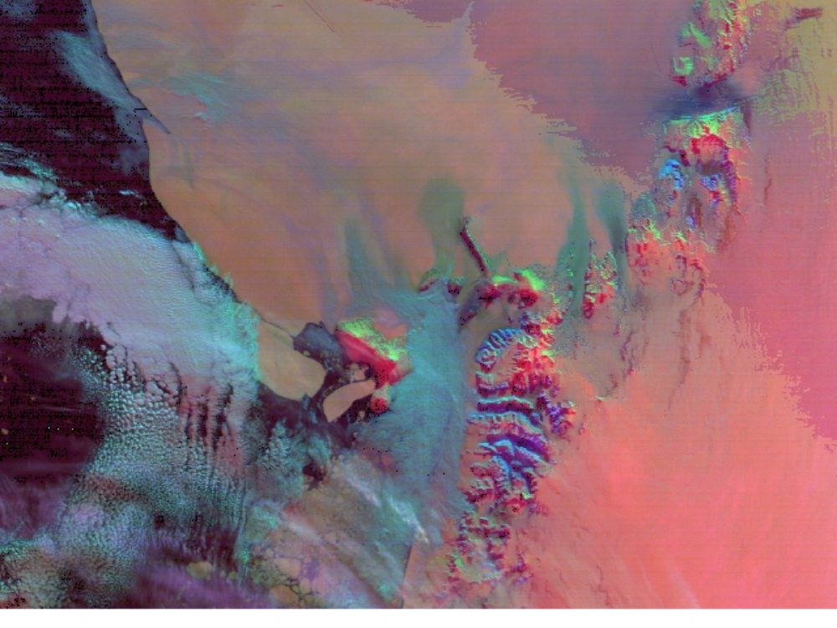
Figure 1 A derived satellite image from the Terra satellite showing a fog event over McMurdo Sound near Ross Island, Antarctica.

