INVESTIGATING ANTARCTIC PRECIPITATION IN THE ROSS ISLAND REGION FROM VARIOUS OBSERVING PLATFORMS

Shelley L. Knuth*, Gregory J. Tripoli, and Charles R. Stearns
University of Wisconsin-Madison

1. INTRODUCTION

Determining the precipitation distribution across Antarctica presents challenges not found in the mid-latitudes. A lack of sufficient numbers of in situ measurements and the ambiguities resulting from blowing snow prevent continent-scale mapping of precipitation by traditional methodologies. Alternatively, precipitation estimation using remote sensing by satellite has been suggested, but the complexities of estimating snowfall over snow-covered Antarctica using microwave data present new difficulties that are also unique to the polar environment. This study examines a variety of methods, including surface measurements, satellite data, and model simulations to detect precipitation in Antarctica. Acoustic depth gauges, instrumented on University of Wisconsin Automatic Weather Stations (AWS), provide ground measurements on and near the Ross Ice Shelf. A combination of polar orbiting satellite data from Aqua and the National Oceanic and Atmospheric Administration (NOAA) series, including infrared and microwave channels, determine the presence of storm systems. Further examination of cyclones over the Ross Ice Shelf are conducted with the University of Wisconsin Non-hydrostatic Modeling System (UW-NMS), a cloud resolving model, with simulations over Antarctica run on differing precipitating cloud systems. The UW-NMS model simulations will not only verify the existence of storm systems but will supplement the lack of surface measurements. A case study examining the combination of these observing platforms and modeling can be used simultaneously to estimate precipitation over the Ross Ice Shelf and Ross Island areas.

* Corresponding author address: Shelley L. Knuth, AMRC/SSEC, Univ. of Wisconsin, 1225 W. Dayton St., Madison, WI 53706 email: shelleyk@ssec.wisc.edu
2. CHALLENGES IN MEASURING ANTARCTIC PRECIPITATION

There are considerable challenges to measuring snow in the polar regions, with additional complexities unique to Antarctica. Perhaps the greatest challenge is distinguishing between precipitating and blowing snow. Blowing snow represents the mass of snow that is advected away from or on to a location during periods of strong winds (King and Turner, 1997). The acoustic depth gauges (ADG) onboard the AWS units, measure only accumulation in an area and do not determine the origination of the snow. Thus, during situations in which dynamical processes occur that would favor precipitation regimes, high winds can advect the precipitating snow out of the measurement area or advect snow from other locations into the measurement area, thus tainting the results. King and Turner, (1997), established a blowing snow threshold of 5 m/s, which indicates that the snow in areas where the wind speed is greater than 5 m/s will be advected out of the region, while snow in areas in which the wind speed is less than 5 m/s will remain in its original location. King and Turner found that the amount of blowing snow across the area is dependent on both temperature and wind speed. At higher wind speeds and lower temperatures, the snow will be more likely to be advected into a region, while higher temperatures and lower wind speeds will tend to deter blowing snow.
Attempts to measure polar precipitation by satellite also present considerable challenges. Using microwave data to determine the amount of precipitating snowfall presents difficulties in distinguishing the emissivities of falling snow versus the snow already at the surface. Using a combination of microwave frequencies may be able to help alleviate this issue. Further difficulties are have been revealed while studying the dynamics of precipitation on the Ross Ice Shelf and near Ross Island. The Transantarctic Mountains and the nearby ocean provide different dynamical forcing regimes for precipitation formation, such as cold air damming or synoptic systems originating from the Ross Sea. By using a non-hydrostatic cloud modeling system, such as the University of Wisconsin Non-hydrostatic Modeling System (UW-NMS), deciphering the origination of precipitation formation can be found.

3. METHODOLOGY

In order to determine the amount of accumulation in an area that results from precipitating systems, a combination of methods is used, including in situ measurements, satellite observations, and model output. The in situ measurements come from both the AWS units and the ADG measurements, as well as through visual stratigraphy.
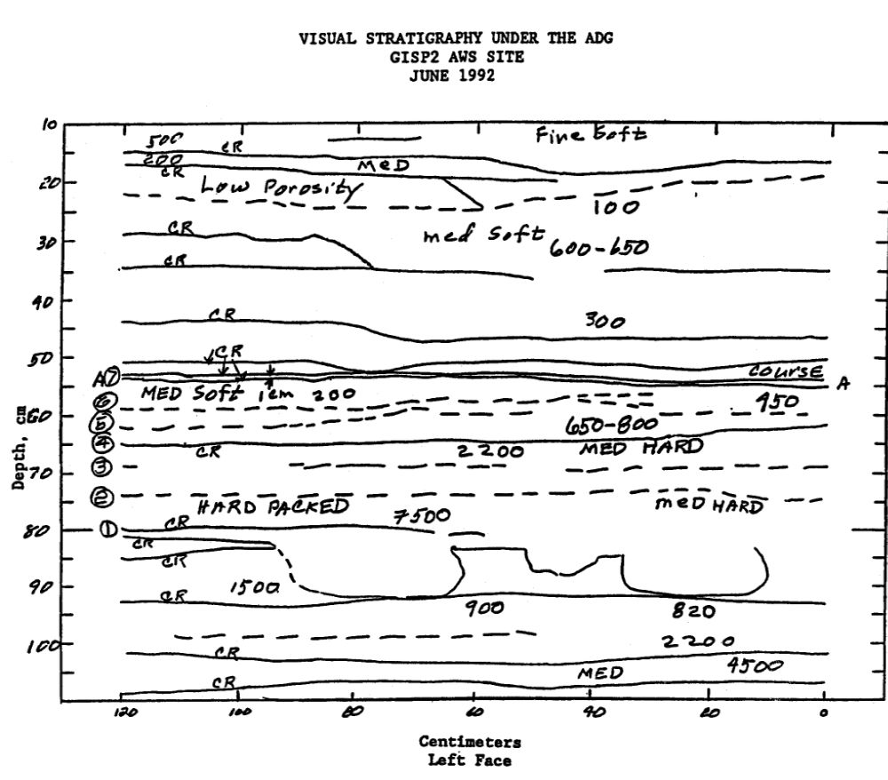

Figure 1. Visual stratigraphy under the ADG at the GISP2 AWS to a depth of about 1.9 m. From Stearns and Weidner, 1993.

The effect of blowing snow requires other, less conventional means of achieving an accurate quantitative description of accumulation by precipitation at an ADG site. For example, visual stratigraphy can be performed in an area beneath the ADG site in order to achieve a depiction of the layers of snowfall in a region over the course of a period of time. Stearns and Weidner, (1993), used this methodology to represent the net snow accumulation at GISP2 site on the Greenland crest (Figure 1). Accumulation was measured by inspecting the layers of snow in the area underneath the ADG. Determination of the type of accumulation can be inferred by examination of the synoptic situation at the time of accumulation by combining results of the ADG, wind speed and direction, temperature and relative humidity profiles, and the cross-sectional area of the visual stratigraphy profile. For the GISP2 site in Greenland, the layer between (6) and (7) labeled on Figure 1 was earmarked as entirely accumulation due to precipitation. This is because of low wind speeds during the 1992 October 21-23 time period, which is the time period representative of the layer between (6) and (7) (Figure 2). The wind speeds during this October time frame were below the blowing snow threshold of 5 m/s, marked on the plot of wind speed vs. time.
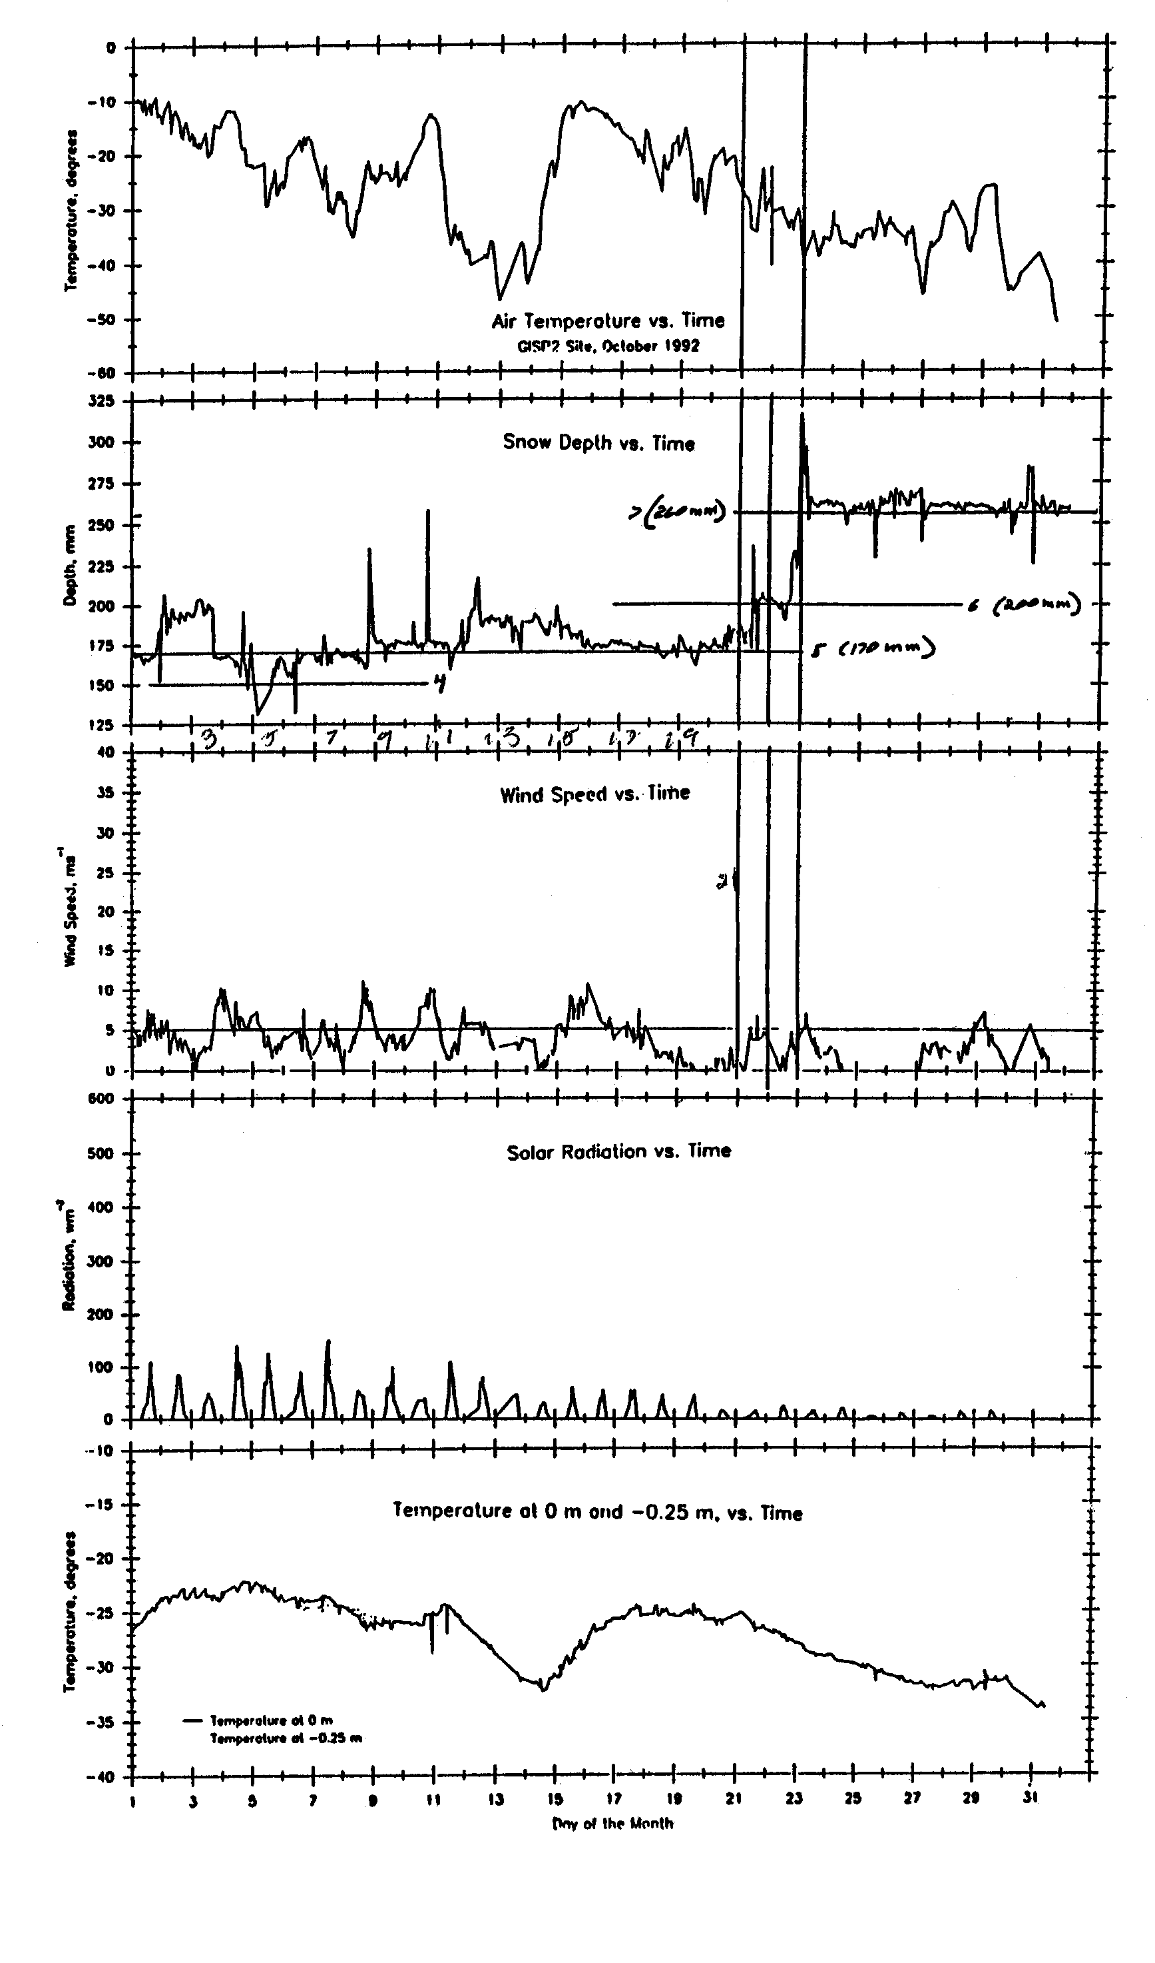
Figure 2. Graph of air temperature, snow depth, wind speed, solar radiation, and the snow temperature at 0 m and -.025 m at GISP2 AWS site for the period of 1 October through 31 October 1994.
Satellite observations will also be used to determine if there is a cloud system present from which precipitation can occur. A combination of infrared and visible images from NOAA polar orbiting satellites will be used to determine the location of synoptic cloud systems, as well as any other features that could develop precipitation. As well, the 89 GHz channel of the AMSR-E sensor on board the MODIS Aqua satellite will be used to attempt a depiction of falling precipitation.
The third method for determining precipitation comes from the utilization of the UW-NMS model. The UW-NMS is a cloud resolving model that uses a variable step topography scheme, which is desirable for resolving the topography near the Ross Island region. The UW-NMS can also depict different ice particles in a cloud, giving a more descriptive look at the microphysical processes within a cloud system. Furthermore, this model can be used to place synoptic systems, determine the origin of dynamical processes that cause precipitation, and interpolate data between measurement points.

4. INSTRUMENTATION

This project works with a suite of Automatic Weather Stations (AWS) outfitted across the Antarctic continent, including a region on and near the Ross Ice Shelf that is populated with an above average number of AWS units that is an area of interest to this project. The AWS units in Antarctica are unmanned stations that take basic weather measurements (temperature, wind speed and direction, pressure, relative humidity, and vertical temperature difference) in some of the harshest areas of the continent. The wind speed and direction, relative humidity, and temperature sensors are mounted at a nominal level of 3 meters at the top of the unit (Figure 3). Air pressure is measured at the midpoint level within the enclosure box, and the vertical temperature difference is measured between the tower top and .5 meters from the surface (Stearns et. al, 1993). The data is stored on a datalogger on board the system as well as transmitted via the SERVICE ARGOS data collection system (DCS) on board the NOAA satellite series. In 2004, there were approximately sixty AWS units operating across the continent, with about fifteen operating in the McMurdo region.

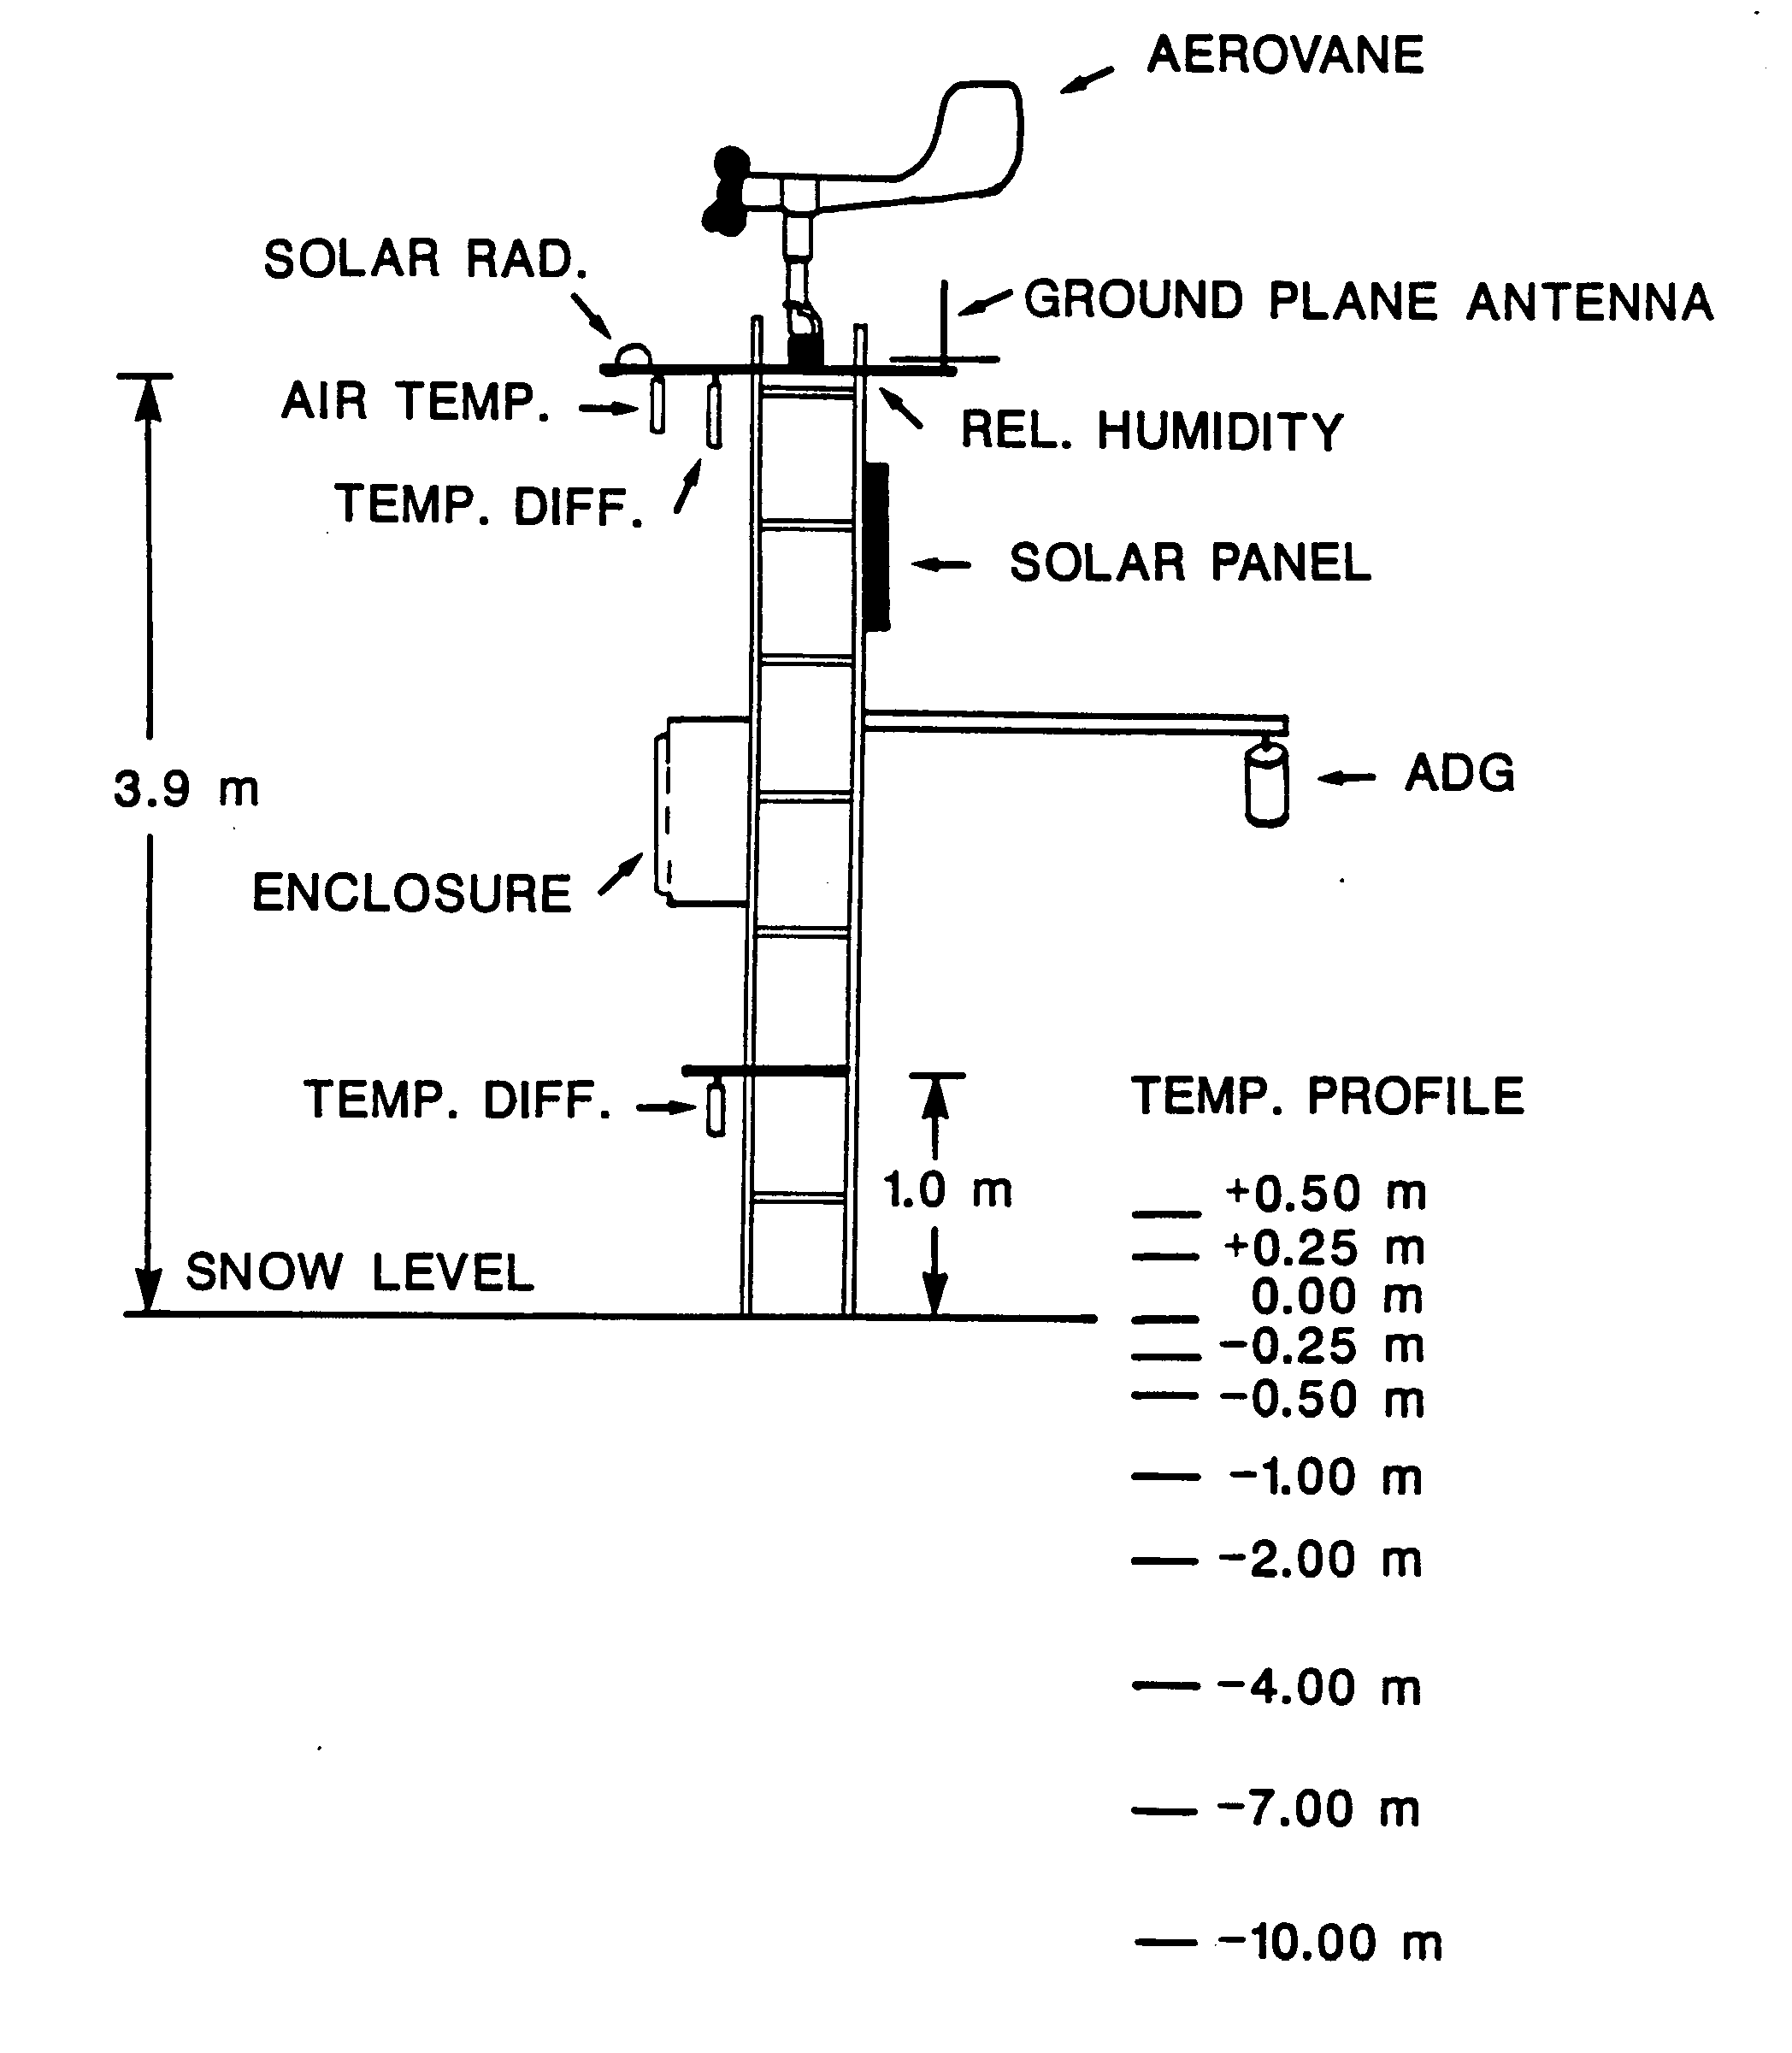
Figure 3. Schematic representation of an AWS unit.

The acoustic depth gauges (ADG) used are designed by Campbell Scientific, Model UDG01. The units are mounted on board the AWS stations at two sites located near McMurdo – Williams Field at 77.87ºS 166.98ºE, and the B-15A iceberg, located at 77.06ºS 169.02ºE. The units measure the depth of the snow by bouncing a series of pulses off of the snow surface and listening for the return echo. The distance from the ADG to the snow surface is measured by the amount of time it takes for the sound wave to return to the ADG after transmission. Outfitting the ADGs on board the AWS units is advantageous for a number of reasons, including the fact that the AWS units measure values that are desired to be taken simultaneously with the ADG measurements, including wind speed and direction measurements, temperature, and relative humidity.
During the 2003-2004 Antarctic field season, the AWS team deployed one ADG unit at Williams Field. This ADG was intended to compliment the second unit in place at B-15A.

5. CASE STUDY – 26 APRIL 2004

The case study from 26 April 2004 was a

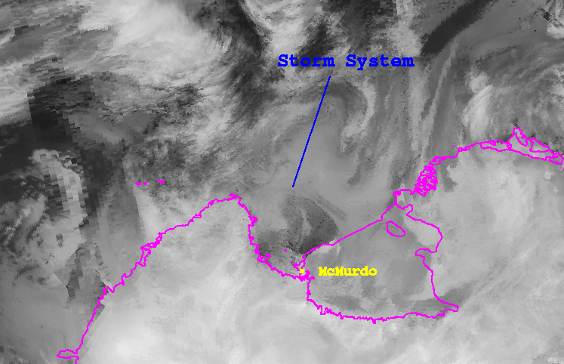

Figure 4. Antarctic Meteorological Research Center (AMRC) 10.7 μm infrared satellite composite image depicting the low pressure system entering McMurdo Station on the Ross Ice Shelf on 26 April 2004 at 12 UTC.

typical autumn storm, chosen as such to avoid high wind situations, and thus reduce the blowing snow effect. The storm was prompted primarily by a low pressure system that entered the McMurdo area from the eastern Ross Ice Shelf (Figure 4). Visibilities during this time were reported by the McMurdo forecasters as being less than 100 feet (Knuth et. al, 2004).
This late April storm lasted from approximately 7:00Z on 26 April until 17:00Z on 27 April. During this time, there were two Condition 2 periods declared, and one Condition 1. A Condition 2 period, set by forecasters in McMurdo, indicates that either there is a sustained wind speed between 25 and 28 m/s, visibilities are between ¼ mile and 100 feet, or the wind chill temperature is between -60°C and -73°C. A Condition 1 period indicates that either there is a sustained wind speed greater than 28 m/s, visibilities are less than 100 feet, or the wind chill temperature is colder than -73°C. Condition 3 is set when conditions are better than Condition 2.
The ADG at Williams Field reported a maximum accumulation of 2 cm at 1:00Z on 26 April. The Williams Field ADG is only programmed to take measurements once per day at 1:00Z, so this measurement indicates the accumulation for the period twenty-four hours prior to the measurement time. Examination of Figure 5 shows that this accumulation was caused by both blowing snow and precipitation. Throughout this time period, the wind maximum never exceeded 17 m/s, so the Condition 2 and Condition 1 periods were declared due to poor visibility or cold temperatures. During the first Condition 2 and Condition 1 period from 7:23Z to 10:25Z on 26 April, wind speeds did not exceed the 5 m/s blowing snow maximum until very end of the period. During this time, however, the relative humidity profile remained fairly uniform, thus indicating precipitation. Consequently, accumulation during this period was determined to be due to precipitation.
During the second Condition 2 period, from 16:11Z on 26 April to 15:00Z on 27 April, accumulation was not entirely due to precipitation. In the beginning part of this period, wind speeds were above the blowing snow threshold. Relative humidity levels remained constant, indicating the existence of a deep layer of precipitation rather than a

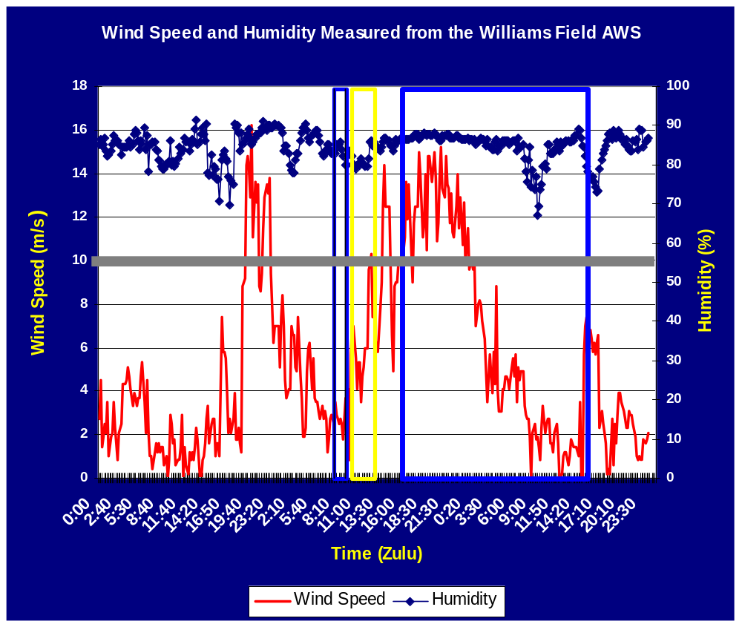

Figure 5. AWS measurements at Williams Field from 0Z on 25 April 2004 until 23:59Z on 27 April 2004 showing wind speed (m/s) and relative humidity (%). The gray line shows all wind speeds below 5 m/s. The blue box indicates a Condition 2 period, and the yellow box indicates a Condition 1 period.

shallow (entraining) layer of blowing snow. It is therefore believed that during this period the accumulation was divided between periods of precipitation and blowing snow. However, during the middle portion of that period, the discontinuity of the relative humidity profile indicated that precipitation was not occurring for that period. Near the end, the continuous relative humidity profile indicated it was again precipitating. This time, the wind speed was well below the blowing snow threshold, indicating that any accumulation would be occurring from precipitation.
During the first period at 10:00Z on 26 April, the UW-NMS was predicting that the dynamics of the Ross Island area was suitable for precipitation. Cold air damming along the Transantarctic Mountains due to synoptic flow formed precipitation along the lee side of the mountains. This, as well as the low pressure system present in the area, created precipitation in the McMurdo area (Figure 6).
A third method to verify falling precipitation against is through the examination of microwave data. Microwave data depict brightness temperatures, which can be converted to emissivity values. If the brightness temperatures over time vary in an area, precipitation can be determined to fall in that area. Figure 7 shows the 89 GHz microwave channel of AMSR-E data from Aqua, with brightness temperatures from 260K to 300K enhanced. This image from 13:01Z on 27 April shows precipitation falling in the area near McMurdo, near the time of the precipitation accumulation at the Williams Field ADG.
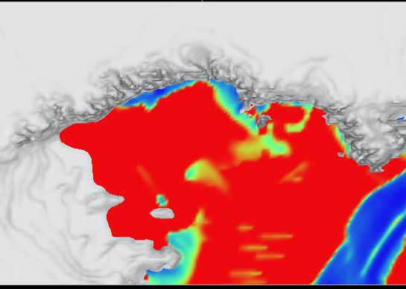

Figure 6. UW-NMS simulation from 10:00Z on 26 April depicting precipitation along the Transantarctic Mountains and Ross Island.

6. SUMMARY

Precipitation in Antarctica, especially near Ross Island, is difficult to quantify. There are many unique challenges related to detecting precipitation, including blowing snow, problems with distinguishing the emissivities of falling versus stationary snow at the surface through microwave data, as well as a blend of various topographical influences on the weather in the Ross Island region. The goal of this project is to identify areas with likely precipitation regimes, and by using different methodologies, determine whether or not precipitation is falling in a region. Through a combination of in situ measurements, satellite output, and model simulations, dynamical processes contributing to precipitation are being determined. Surface based measurements, such as from AWS stations, ADG units, and visual stratigraphy methods will contribute as a ground based truth for the presence of accumulation. Satellite output from infrared and microwave imagery will also both place the location of synoptic or other precipitating systems, as well as use brightness temperatures to determine precipitation estimation. Simulations from the UW-NMS model will not only interpolate data between scarce data points, but also provide insight into the dynamical processes causing precipitation.

Acknowledgments
The authors wish to thank Amanda Adams for supplying the UW-NMS images. This work was supported by the National Science Foundation Grant No. OPP-0088058. 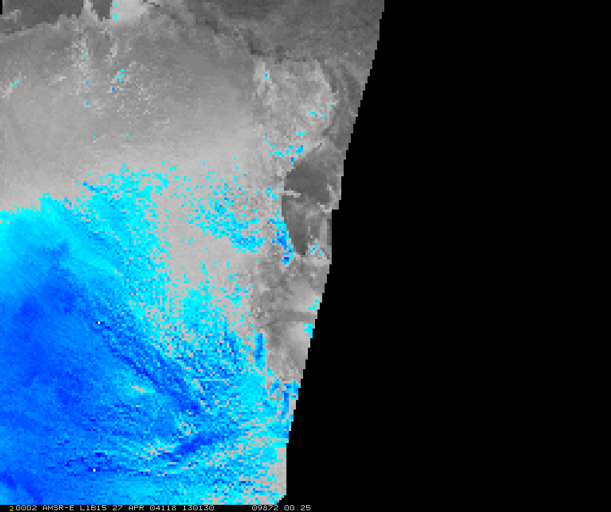

Figure 7. 89 GHz AMSR-E image from 13:01Z on 27 April. Brightness temperatures between 260 and 300K are enhanced. Precipitation can be seen on Ross Island.

7. REFERENCES

King, J. C., and J. Turner, 1997, Antarctic Meteorology and Climatology: Cambridge, Cambridge University Press.

Knuth, S.L., G.J. Tripoli, and C.R. Stearns, 2004: Precipitation Measurements on the Ross Island Region, Antarctica. 8th International Conference on Precipitation, Vancouver, British Columbia.

Stearns, C.R., L. Keller, G.A. Weidner, and M. Sievers: Monthly mean climatic data for Antarctic automatic weather stations. Antarctic Research Series, Vol. 61, 1-22, 1993.

Stearns, C.R. and G.A. Weidner, 1993: Greenland field report. Space Science and Engineering Center, University of Wisconsin-Madison. Unpublished. Available upon request.

Tripoli, G.J., 1992: A nonhydrostatic mesoscale model designed to simulate scale interaction. Mon. Wea. Rev., 120, 1342-1359.

