01 September, 2015
PalMOS data integration plan

The new Palmer Station Meteorological Observation System (PalMOS) is expected to be operational by 14 September, 2015. As of July 2015, the instruments are all at Palmer Station. They are being bench tested and the software is being tested in the lab. Power and data cables will be run out to the new tower site. (fig 1) The ceilometer and rain gauge platform will be installed, and the system will be logging and sending weather data to meet the 14 September deadline.

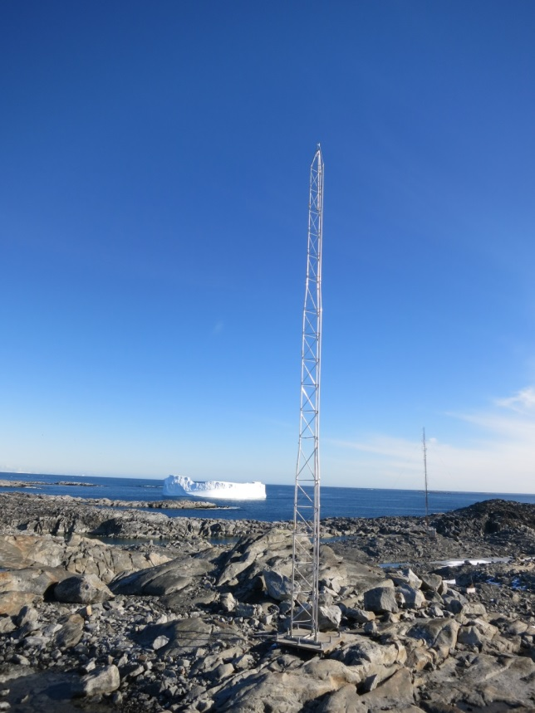
Figure 1: New PalMOS antenna in the backyard
The new PalMOS data will be used to support station operations as soon as it is up and running. The Palmer RA will continue sending weather updates to the Antarctic Meteorological Research Center (AMRC) and Matthew Lazzarra (O-283-P), and providing sitrep data to station management from the new PalMOS when the new site is operational. The weather graphs used on station for operational decisions will come from the new PalMOS system.
Weather data will still be distributed and used in the same way that it has historically been managed.
Things that will not be changing:
- Automated weather reports will be generated and sent for forecasting purposes.
- The new system will graph and display wind and temperature data for operational use at Palmer Station.
- The Palmer Research Associate will continue to send weather updates in the Palmer Station monthly science sitrep.
- Data will be archived at the AMRC repository, pulled monthly by FTP from Palmer Station. Raw files will still be sent to Matthew Lazzara O-283.
- Individual researchers will be able to make data requests from the Palmer Research Associate: pal.ra@usap.gov

What will change:
- The new raw weather output will be in SQL files, bringing the PalMOS system in line with other USAP sites. Researchers may request individual datasets in excel format if desired.
NSF and ASC have committed to running both the new PalMOS system and the old PalMOS system in tandem for at least a year. (Meaning if the old PalMOS system breaks down within the year, funds will be made available to repair it.) The two systems will run simultaneously for as long as old PalMOS keeps running, up to two years. After two years, the old PalMOS system will be dismantled and the tower will be removed. USAP/ASC has no plans to compare the data, but all data will be available to any interested researcher.
Additionally, ASC plans to install several remote weather sites in the Palmer vicinity. There will be an AWS station on the Joubins (fig 2), on the Wauermans (fig 3), and at a third yet to be determined site. These remote AWS stations will only log wind speed and direction, temperature and barometric pressure. They will integrate with the new PalMOS system, and the data will be available for any interested researchers.

Transitional Phase

Demobilization and Final Plan
During the transitional phase, data will be available for old PalMOS, new PalMOS, and the old PalMOS site with the same instruments as the new system. The old PalMOS station will be outfitted with a new remote weather system to run until it is ready to deploy to the field; this will create a third dataset with new instruments at the old weather site. The data will be logged and made available to any interested researchers.
There are additional advantages to adding the new sensor suite to the old tower during the transitional phase. This will ensure that we are running one of the remote sites from the start of the new PalMOS. We will be able to test the HF data links and system integration before deploying them into the field. We will set up the solar power and battery packs at the old PalMOS site in order to test the equipment, monitor power use, identify losses due to snow and ice rime, and potentially make modifications to the system before it’s installed in the field.
The Joubins and Wauermans site installations are planned for late in the 2015-16 summer season. When the third AWS site is identified, the new instrument suite will be removed from the old PalMOS tower and installed at that site. At the end of the transitional period, (September 2017 at the latest) the old PalMOS tower will be retrograded, regardless of whether a new site for the last remote station has been identified.
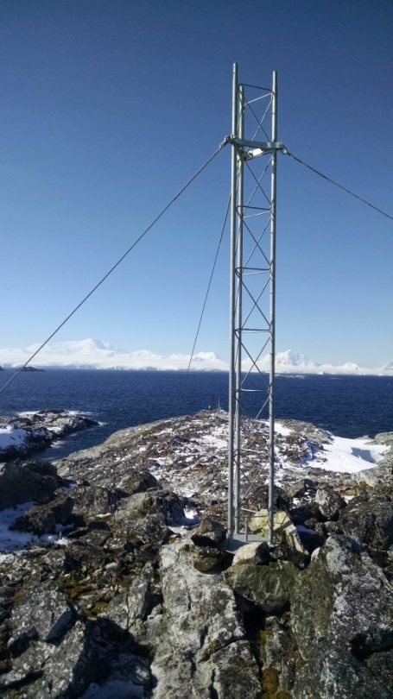
Figure 2: Joubins Weather site
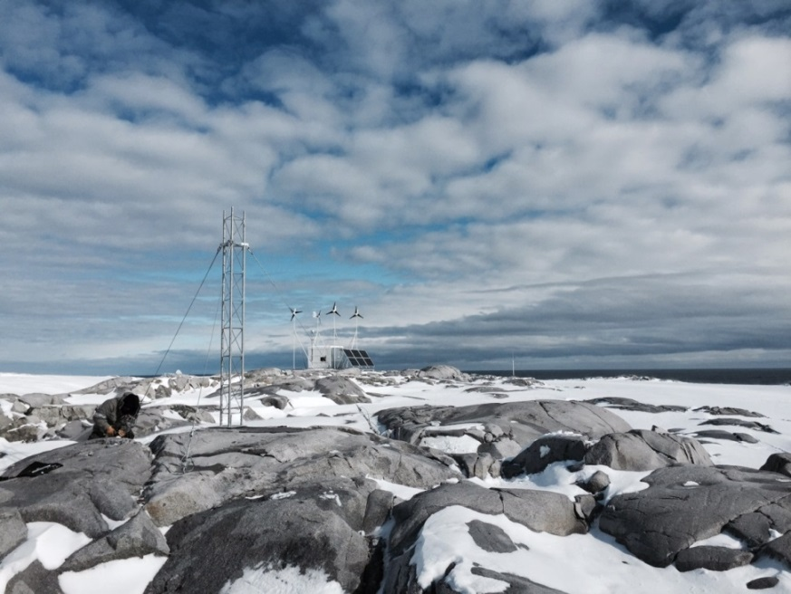
Figure 3: Wauermans weather site
Please direct all comments or suggestions regarding implementation of the new weather system to the Peninsula S&TPS Manager, Jamee Johnson.
Jamee.Johnson.contractor@usap.gov
720 568-2454

