Antarctic Meteorological Engineering
Report 2013:
Review and Recommendations

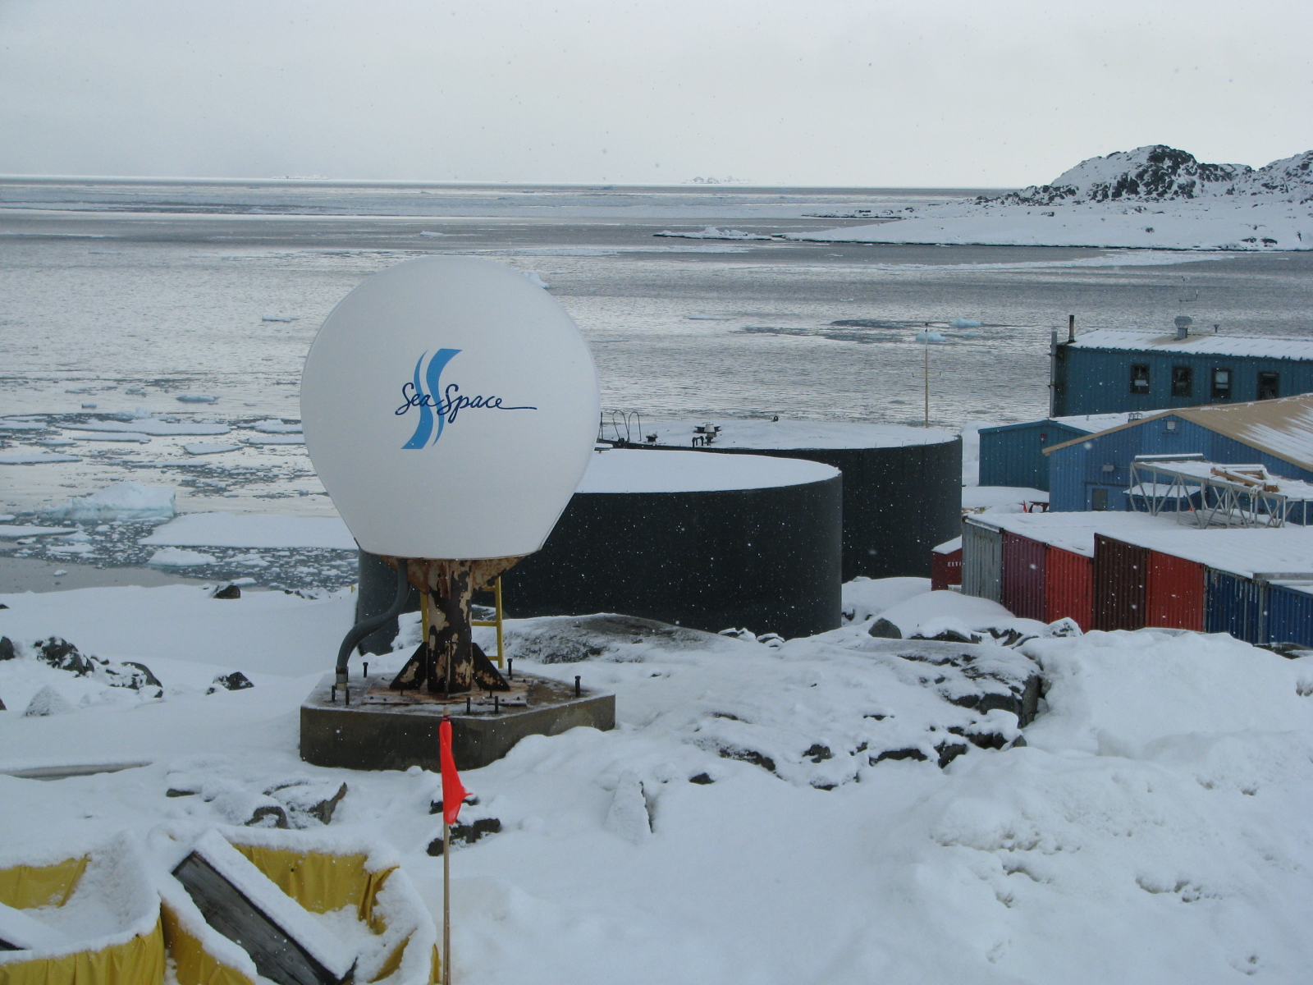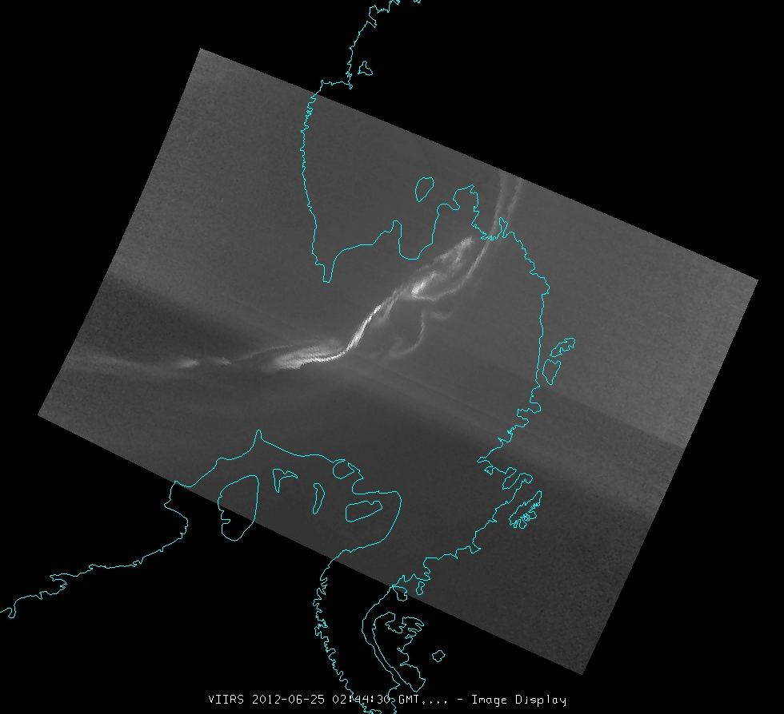

With support from the
SPAWAR Systems Center Atlantic, Polar Programs IPT
Charleston, South Carolina

XXXXXX 2013

Matthew A. Lazzara, PhD
Antarctic Meteorological Research Center, Space Science and Engineering Center
University of Wisconsin-Madison
1225 West Dayton Street
Madison, Wisconsin, USA 53706
Voice: +1 (608) 262-0436
FAX: +1 (608) 263-6738
amrc@ssec.wisc.edu
http://amrc.ssec.wisc.edu
ftp://amrc.ssec.wisc.edu

UW SSEC Publication No.13.XX.LX

Compiled in 2013 by the
Antarctic Meteorological Research Center
Space Science and Engineering Center
University of Wisconsin-Madison

Material in this document may be copied without restraint for library, abstract service, educational, or personal research purposes.

Photos and graphs are not specifically acknowledged are courtesy of the author or the AMRC/SSEC.

This report may be cited as:

Lazzara, M.A., 2013: Antarctic Meteorological Engineering Report 2013: Review and Recommendations. UW SSEC Publication No.13.XX.LX. Space Science and Engineering Center, University of Wisconsin-Madison, XX pp. [Available from The Schwerdtfeger Library, University of Wisconsin-Madison, 1225 W. Dayton St., Madison, WI 53706.]

This report is available from:

The Schwerdtfeger Library
University of Wisconsin-Madison
1225 W. Dayton St.
Madison, WI 53706
UW SSEC Publication No.13.XX.LX
( http://library.ssec.wisc.edu/ )

Or on-line at:

http://amrc.ssec.wisc.edu/publications.php

This report is dedicated to …

Table of Contents

Table of Contents 3
Executive Summary 4
A. Introduction 6
B. Meteorological Satellite Reception Systems 7
B.1. Review 7
B.1.1. McMurdo Station Direct Broadcast Reception System 7
B.1.2. Palmer Station Direct Broadcast Reception System 9
B.1.3. NOAA/NESDIS 12
B.1.4. AFWA 13
B.1.5. AMRC and SSEC Data Center 14
B.1.6. Commercial 15
B.2. Recommendations 16
C. Meteorological Data Exchange 21
C.1. Review 21
C.1.1. AFTN and GTS 21
C.1.2. Antarctic-IDD/LDM 22
C.1.3. Geostationary Relay Systems 25
C.1.4 ADDE Services 25
C.1.5. Secure Shell 26
C.2. Recommendations 26
D. Meteorological Observing 27
D.1. Review 27
D.1.1. McMurdo 27
D.1.1. Palmer Station 27
D.2. Recommendations 28
E. Meteorological Interactive Processing Systems 30
E.1. Review 30
E.1.1 MetApp 30
E.1.2. TeraScan 30
E.1.3. Yosemite/Marta Systems 30
E.1.4. McIDAS 31
E.1.5. Google Earth 32
E.1.6. Web Resources 32
E.1.7. Fixed Displays 32
E.1.8. Miscellaneous 33
E.2. Recommendations 34
F. Acknowledgements 35
G. References 36
H. Appendix 37

Executive Summary

This report outlines the following recommendations regarding the satellite reception systems, meteorological data exchange systems, observing and interactive processing systems in use within the USAP along with the meteorological observing systems:

Recommendation #1: A multi-prong approach in the current fiscal and limited satellite availability environments should be taken to ensure access to satellite observations to support both operational weather forecasting and research activities associated with the USAP. Hence, the USAP needs to have reliable access to direct broadcast satellite data available from McMurdo and Palmer Stations as well as access to data from partner organizations (e.g. AFWA, NOAA, AMRC, etc).

Recommendation #2: The USAP needs to develop a more comprehensive plan for the future of satellite observation availability for primarily its weather forecasting and operational logistics support needs. This plan must include accommodations for training and adoption of new capabilities offered on new satellite series. Secondarily, it needs to also consider the use of this data in support of the USAP research community activities, as appropriate.

Recommendation #3: …

Recommendation #4: The creation of the Antarctic-IDD/LDM system has been a success in linking the research and operational communities within the USAP. Do not let the issues with security ruin that success or impede its progress. Include the LDM developers (who are funded by NSF-AGS) in all future discussions of the network to benefit both the Antarctic-IDD and the NSF-AGS funded effort.

Recommendation #5: Care and oversight for meteorological relay, especially to global systems such as the GTS is not as well cared for as could be (e.g. AWS observations and PIREP/AIREP observations and Palmer Station CLIMAT messages, etc.). Real-time availability of meteorological observations and other data sets are important for inclusion in numerical modeling as well as operational efforts. Support for this effort must be encouraged along with the funding to accomplish it properly.

Recommendation #6: Concerns with meteorological observing: Replace the aging meteorological system at Palmer Station. Any efforts to replace this system should be community based including key users of the data, caretakers and data archivists.

Recommendation #7: For MacWeather and ROF: With a host of various interactive processing systems used across the USAP, the effectiveness of using so many different systems, means and methods should be re-evaluated. While there will be no “one-size-fits-all” solution, some level of reducing the number of platforms and software to work with data should be pursued. Even having roughly 3 systems would perhaps be an ideal goal. One system should be a fusion system that would allow nearly all data types be viewable/useable for forecasters, and provide redundancy. Additionally, systems employ should have the ability for future expansion, allow creativity in product and display creation along with the ability to merge datasets and alarm forecasters when severe weather limits are met. Such an effort to evolve to a newer/smaller toolbox of interactive processing should include forecasters, meteorology managers, and minor representation from the meteorological research/science community.

Recommendation #8: For Palmer Station: Weather resources should match community needs. As with the need to build a team to work on scoping out a future smaller toolbox for weather forecasting at McMurdo Station, the same is the case for the Palmer Station. So aside from reliable and well-maintained instrumentation a simple, easy-to-maintain software system that addresses the immediate operational needs of the Palmer community (typically nice visual displays and graphs) and the long-term requirements for scientific users (observations archived in a simple format at a high temporal resolution, similar to our 2-minute data files) are required.

A. Introduction

The United States Antarctic Program (USAP) has one of the largest, if not the largest, logistical efforts in leading research activities in the Antarctic with over 700 aircraft missions per year (Figure 1), two research vessels operating year round, two vessel-resupply missions per year, 3 permanent stations and a host of summer field camps. Meteorological observations and data sets are critical for weather forecasting and the safe operations of the USAP, as overseen by the National Science Foundation (NSF). This report reviews the satellite reception systems, meteorological data exchange systems, and interactive processing systems in use within the USAP. Meteorological observing systems are also integrated into this report. Recommendations are provided within each of these areas to lead toward improvements and efficiencies for the program with a goal of establishing a meteorological architecture.

Figure 1. The LC-130 as operated by the 109th New York State Air National Guard is one of many logistical platforms used by the US Antarctic Program to support science across the Antarctic. The USAP meteorological enterprise contributes to the safety of all Antarctic operations and continues to gain an understanding of the weather and climate of the continent.

B. Meteorological Satellite Reception Systems

The USAP hosts direct broadcast reception systems at both McMurdo Station, and Palmer Station that are assets owned by the National Science Foundation, and administered by the Antarctic Support Contractor (ASC)/Lockheed Martin Corporation. Beyond these systems, the USAP has other avenues available for satellite observations via academic, government and commercial means. These sources of meteorological satellite observations are reviewed in this section with recommendations following that.

B.1. Review

B.1.1. McMurdo Station Direct Broadcast Reception System

McMurdo Station hosts two direct broadcast reception systems atop building 165 (Figure 2). These systems are dedicated to primarily weather forecasting support along with the secondary role of science support activities. Both systems installed are TeraScan systems. Both systems are 2.4-meter X-, S-, and L-band acquisition antennas. They are controlled by a custom SeaTel/Quorum/SeaSpace tracking system. A set of Linux computing systems manages the processing of the data stream captured by these systems. Weather forecasters in the McMurdo Weather Forecast Office (Mac Weather) use two TeraScan display systems as do forecasters at the Remote Operations Facility (ROF) in Charleston, SC. The Antarctic Meteorological Research Center (AMRC) University of Wisconsin-Madison (UW-Madison) receives a clock and data output from both antenna chains on station. The clock and data feeds are connected UW-Madion’s Space Science and Engineering Center (SSEC) Desktop Ingestor (SDI) systems that in turn decode the AMRC/UW-Madison and other international Automatic Weather Station (AWS) across the Antarctic continent. The AWS observations are relayed to forecasters, researchers and the general public. L-band only (National Oceanic and Atmospheric Administration (NOAA)/Polar-orbiting Operational Environmental Satellite (POES) series) of polar-orbiting satellite imagery from the SDI systems are used by AMRC in the creation of its unique Antarctic satellite composites (Figure 3).

Additional satellites are acquired at McMurdo Station with these direct broadcast reception systems, including the Defense Meteorological Satellite Program (DMSP) military satellite series, Aqua and Terra National Aeronautical and Space Administration (NASA) research satellite series and the occasional Suomi-National Polar Platform (NPP) satellite. Weather forecasters via the TeraScan system use the DMSP, Aqua and Terra data. The SDI system historically were able to use the DMSP data, but have not been able to in the last several years as this portion of the SDI system has not been updated due to limited funding. One of the biggest challenges in working with the DMSP data on both the TeraScan systems and on AMRC systems has been the accuracy of the navigation and navigation model.

Aqua and Terra preprocessed data files are provided to AMRC server systems located in the Joint Satellite Operations Center (JSOC), where they are used to generate atmospheric motion vectors (AMV) which are in turn ingested into the Antarctic Mesoscale Prediction System (AMPS). AMPS is the primary modeling system, also known as Polar Weather Research and Forecasting (WRF) model, is supported by the NSF and used by the USAP weather forecasters. Other products are generated by AMRC server systems from the Aqua and Terra data streams. These products have been demonstrational for the USAP weather forecasters. MODIS imagery is also used in AMRC composite imagery. Suomi-NPP data, which acquired by the TeraScan system is not processed by that system, but is being acquired in a demonstrational mode. Instead, this data stream is moved to an AMRC server system in JSOC and processed using the UW-Madison’s Community Satellite Processing Package (CSPP) system. The CSPP, funded by the NOAA Joint Polar Satellite System (JPSS) project, is able to process the Suomi-NPP sensor data including Visible Infrared Imager Radiometer Suite (VIIRS), Advanced Technology Microwave Sounder (ATMS), and Cross-track Infrared Sounder (CrIS) instruments. Quick-look imagery from these is generated as a demonstration for USAP weather forecasters. Selected VIIRS imagery is also in the process of being made available to be a part of the AMRC Antarctic composite imagery (Figure 3).

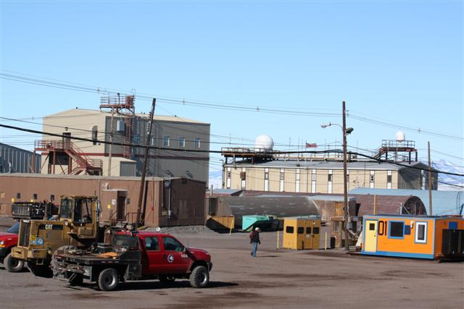
Figure 2. McMurdo Station as seen with McMurdo building 165 in the background and the satellite reception systems atop the building (Courtesy of Corey Anthony, NSF via usap.gov photo library).
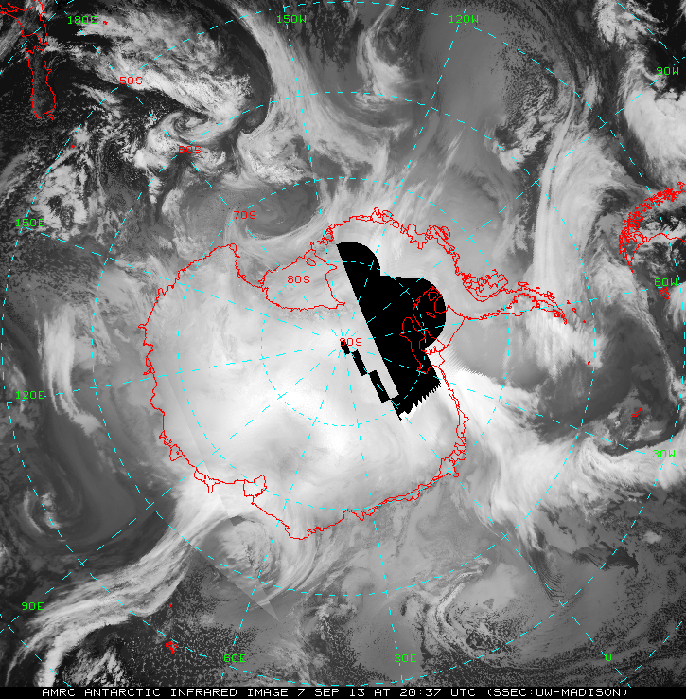
Figure 3. An AMRC infrared Antarctic satellite image from 7 September 2013 at 20 UTC depicts the storms and clouds about the Antarctic and Southern Ocean. The black area in the middle is a region of no coverage due to no available satellite observations that qualified to be used at this time.

B.1.2. Palmer Station Direct Broadcast Reception System

Palmer Station hosts one direct broadcast reception system that has been historically used in support of science activities as well as used in local logistical decision-making (e.g. zodiac operations). The system installed there is a TeraScan system with a 1-meter, dual L-band/S-band acquisition antenna, controlled by a SeaTel Tracking Antenna Control Unit (Figure 4 and Figure 5a). A Linux computer system manages the processing and runs the TeraScan software system for display. Satellites acquired by the system include the NOAA/POES civilian polar-orbiting satellite series, DMSP military satellite series and the European Metop-B satellite. Historically, this system acquired the OrbView-2 satellite with the Sea-viewing Wide Field-of-view Sensor (SeaWiFS) ocean color sensor system. As of end of February 2011, the OrbView-2 satellite is no longer operating, and this data is no longer acquired at Palmer Station.

The satellite observations acquired at Palmer station are used for operational planning and science research activities (Figure 5b). The observations primarily used include the visible, infrared and microwave data from the NOAA/POES and DMSP satellite series. Additional data. In the past, ozone and other encoded weather data was used from the NOAA data stream. The USAP weather forecasters also use the satellite imagery, as the data is provided to them at the ROF in Charleston, SC.

An additional user of the observations is the AMRC/UW-Madison. As with the observations from McMurdo Station, the data is primarily used in the creation of the Antarctic satellite composite imagery (Kohrs et al. 2013, Lazzara et al. 20xx, Lazzara et al. 20xx) (Figure 3). Just as it is setup at McMurdo Station, one additional dataset uniquely made available from the direct broadcast system are AWS observations embedded in the NOAA/POES HRPT data stream. These observations are available in the TeraScan system however the software sub-package that works with this data is outdated and likely does not correctly decode more recent AWS systems. An AMRC/SSEC SDI system is also installed in the Terra Lab that does the decoding of the AWS observations and serving of the NOAA/POES HRPT observations. It had abilities to work with the DMSP satellite observations captured by Palmer’s system, but that is currently a degraded capability.

Figure 4. The TeraScan reception antenna pedestal at Palmer Station holds a 1-meter dual L-band/S-band tracking antenna system. (Photo courtesy of Glenn Grant, ASC/NSF)

a. 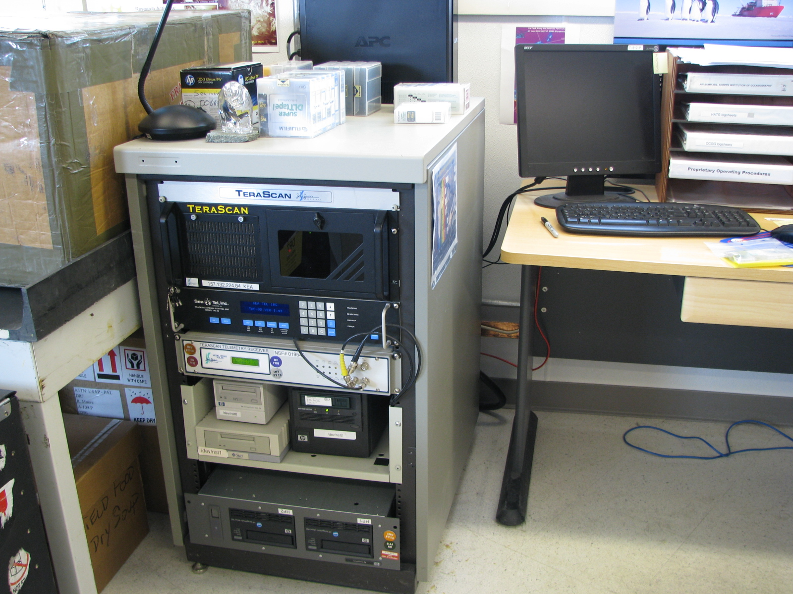 b.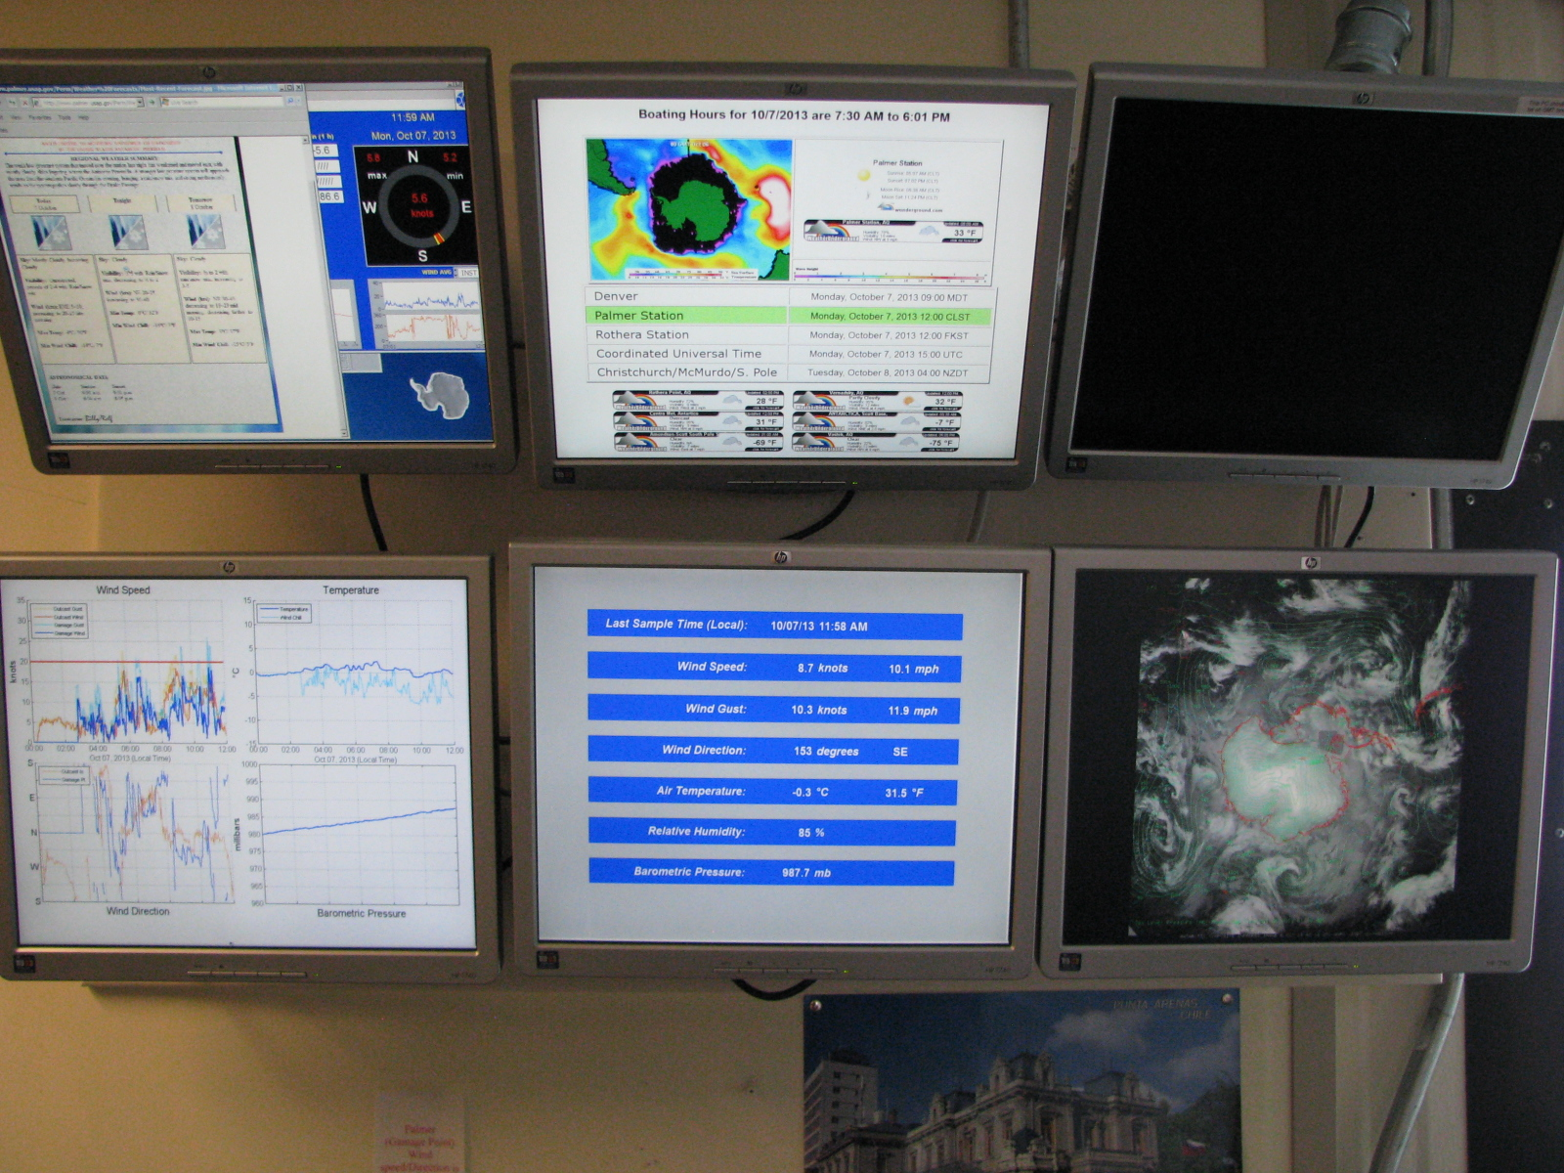
Figure 5. a) TeraScan processing unit installed at Palmer Station b) Weather display area that provides a host of weather information include imagery from the TeraScan system, satellite composites with isobar overlay from AMRC, local PalMOS observations and more (Photos courtesy of Glenn Grant, ASC/NSF)

B.1.3. NOAA/NESDIS

NOAA’s National Environmental Satellite Data and Information Service (NESDIS) may be an alternative source for satellite imagery and data (Figure 6). NOAA/NESDIS data operations offer a host of global satellite data sets from geostationary and polar-orbiting satellite platform (See Table 1). These datasets are made available via ADDE services (See Section C.1.4.). In addition, a subset of these datasets is also made available via NOAA’s NOAAport service (See Section C.1.3), however, generally with little focus on the Antarctic. Other data providing methods are utilized by NOAA, including a rebroadcast of the captured NOAA/POES and MetOp data streams via domestic geostationary satellite (DOMSAT) (See Section C.1.3) to make the data available to users within the US including, AFWA, UW-Madison, and other users within NOAA, to name a few. At times, some of the key data are often not available for hours after it is acquired/observed by the satellites, there by impacting its value for weather forecasting and real-time applications (e.g. logistics planning, etc.).

a.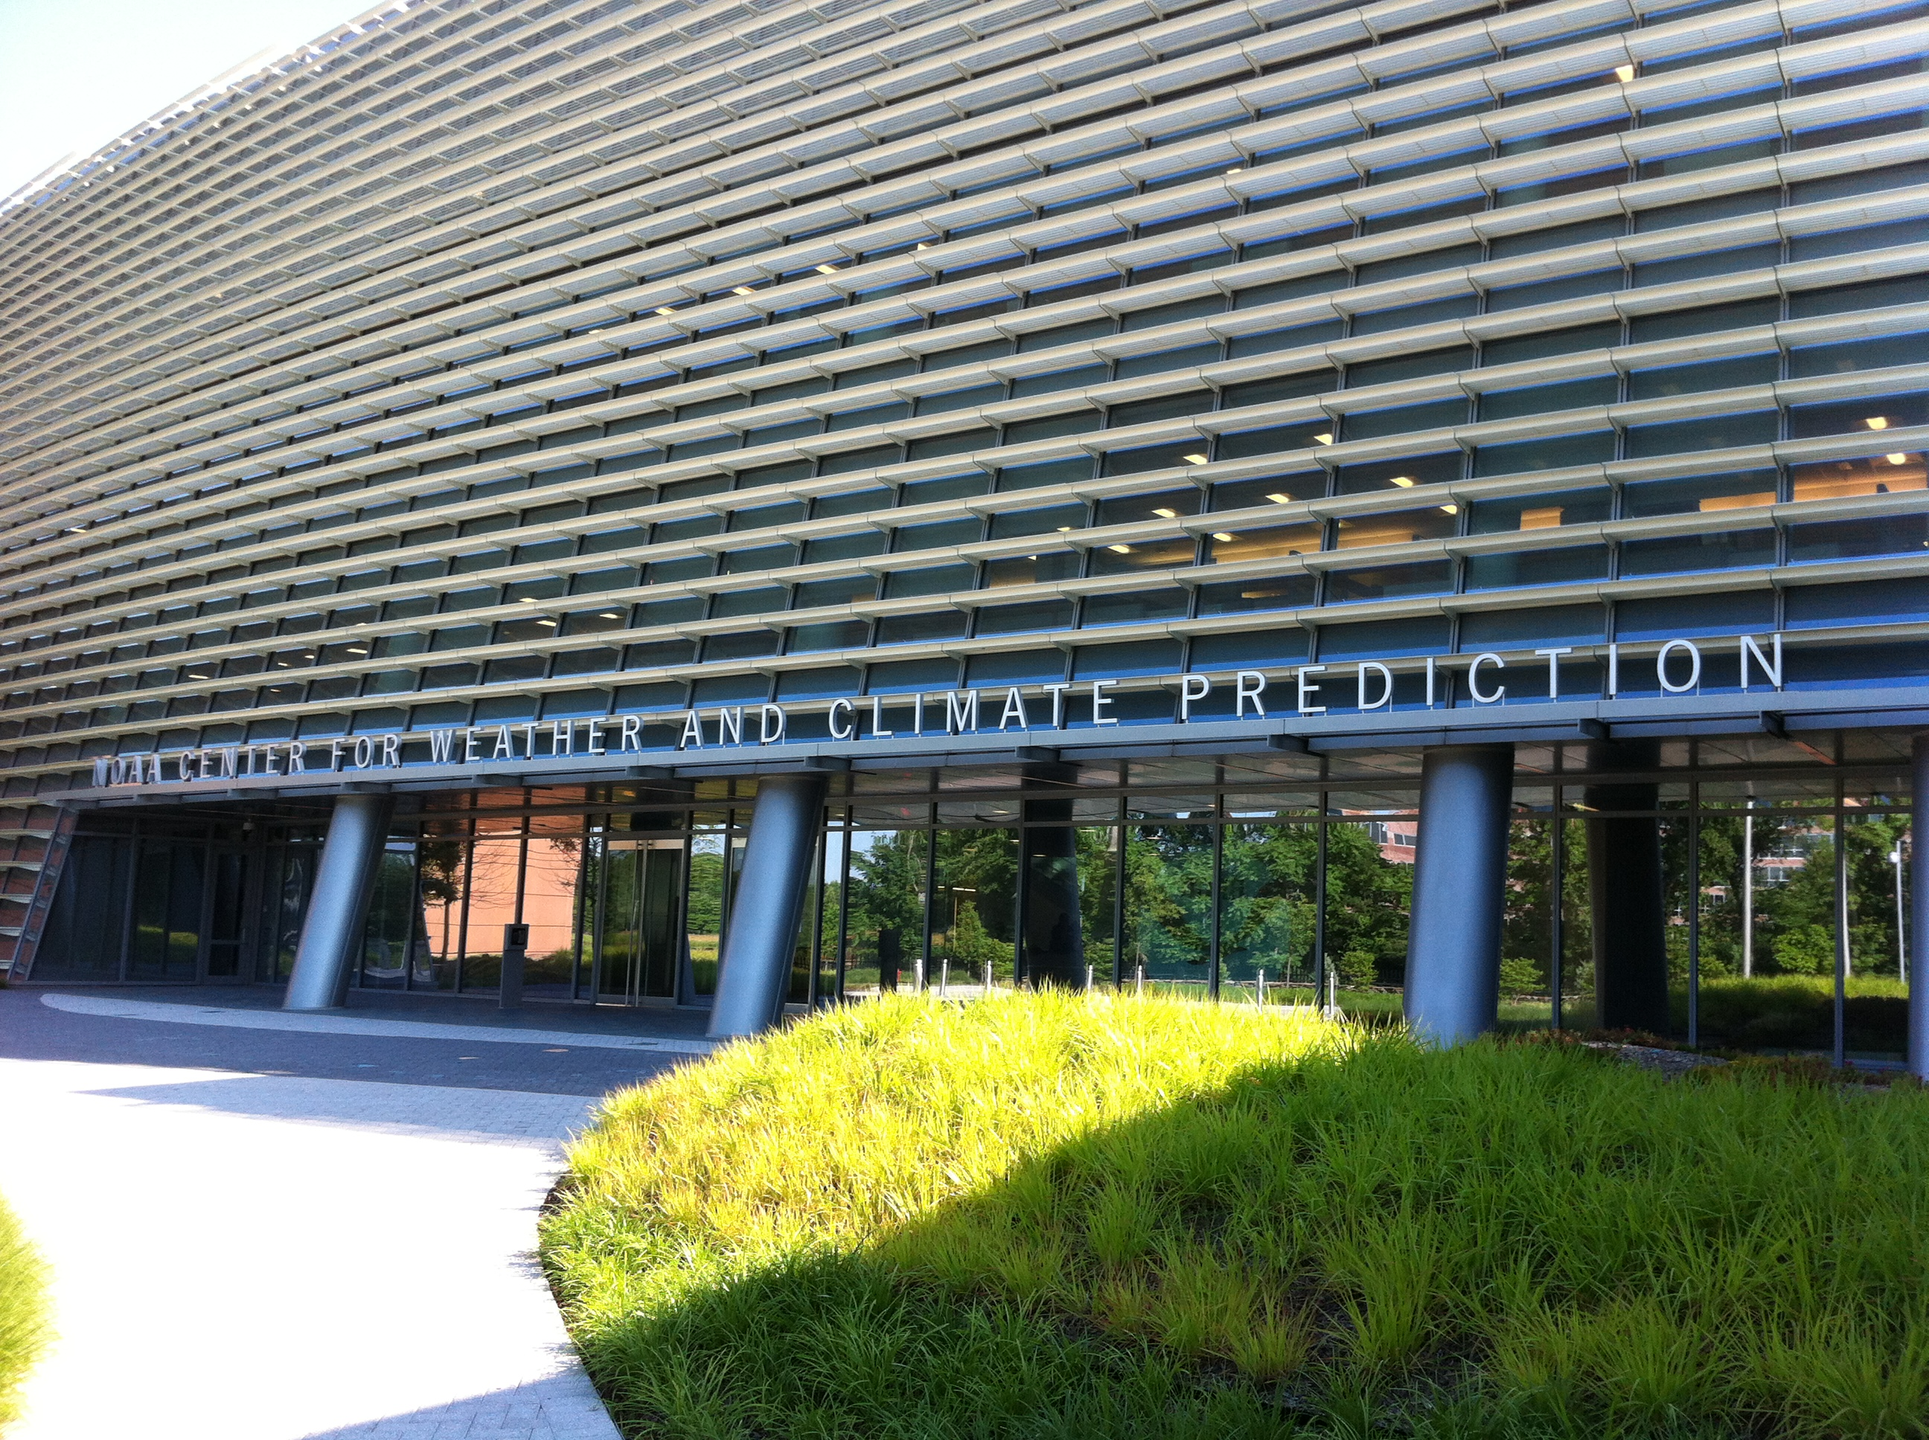 b.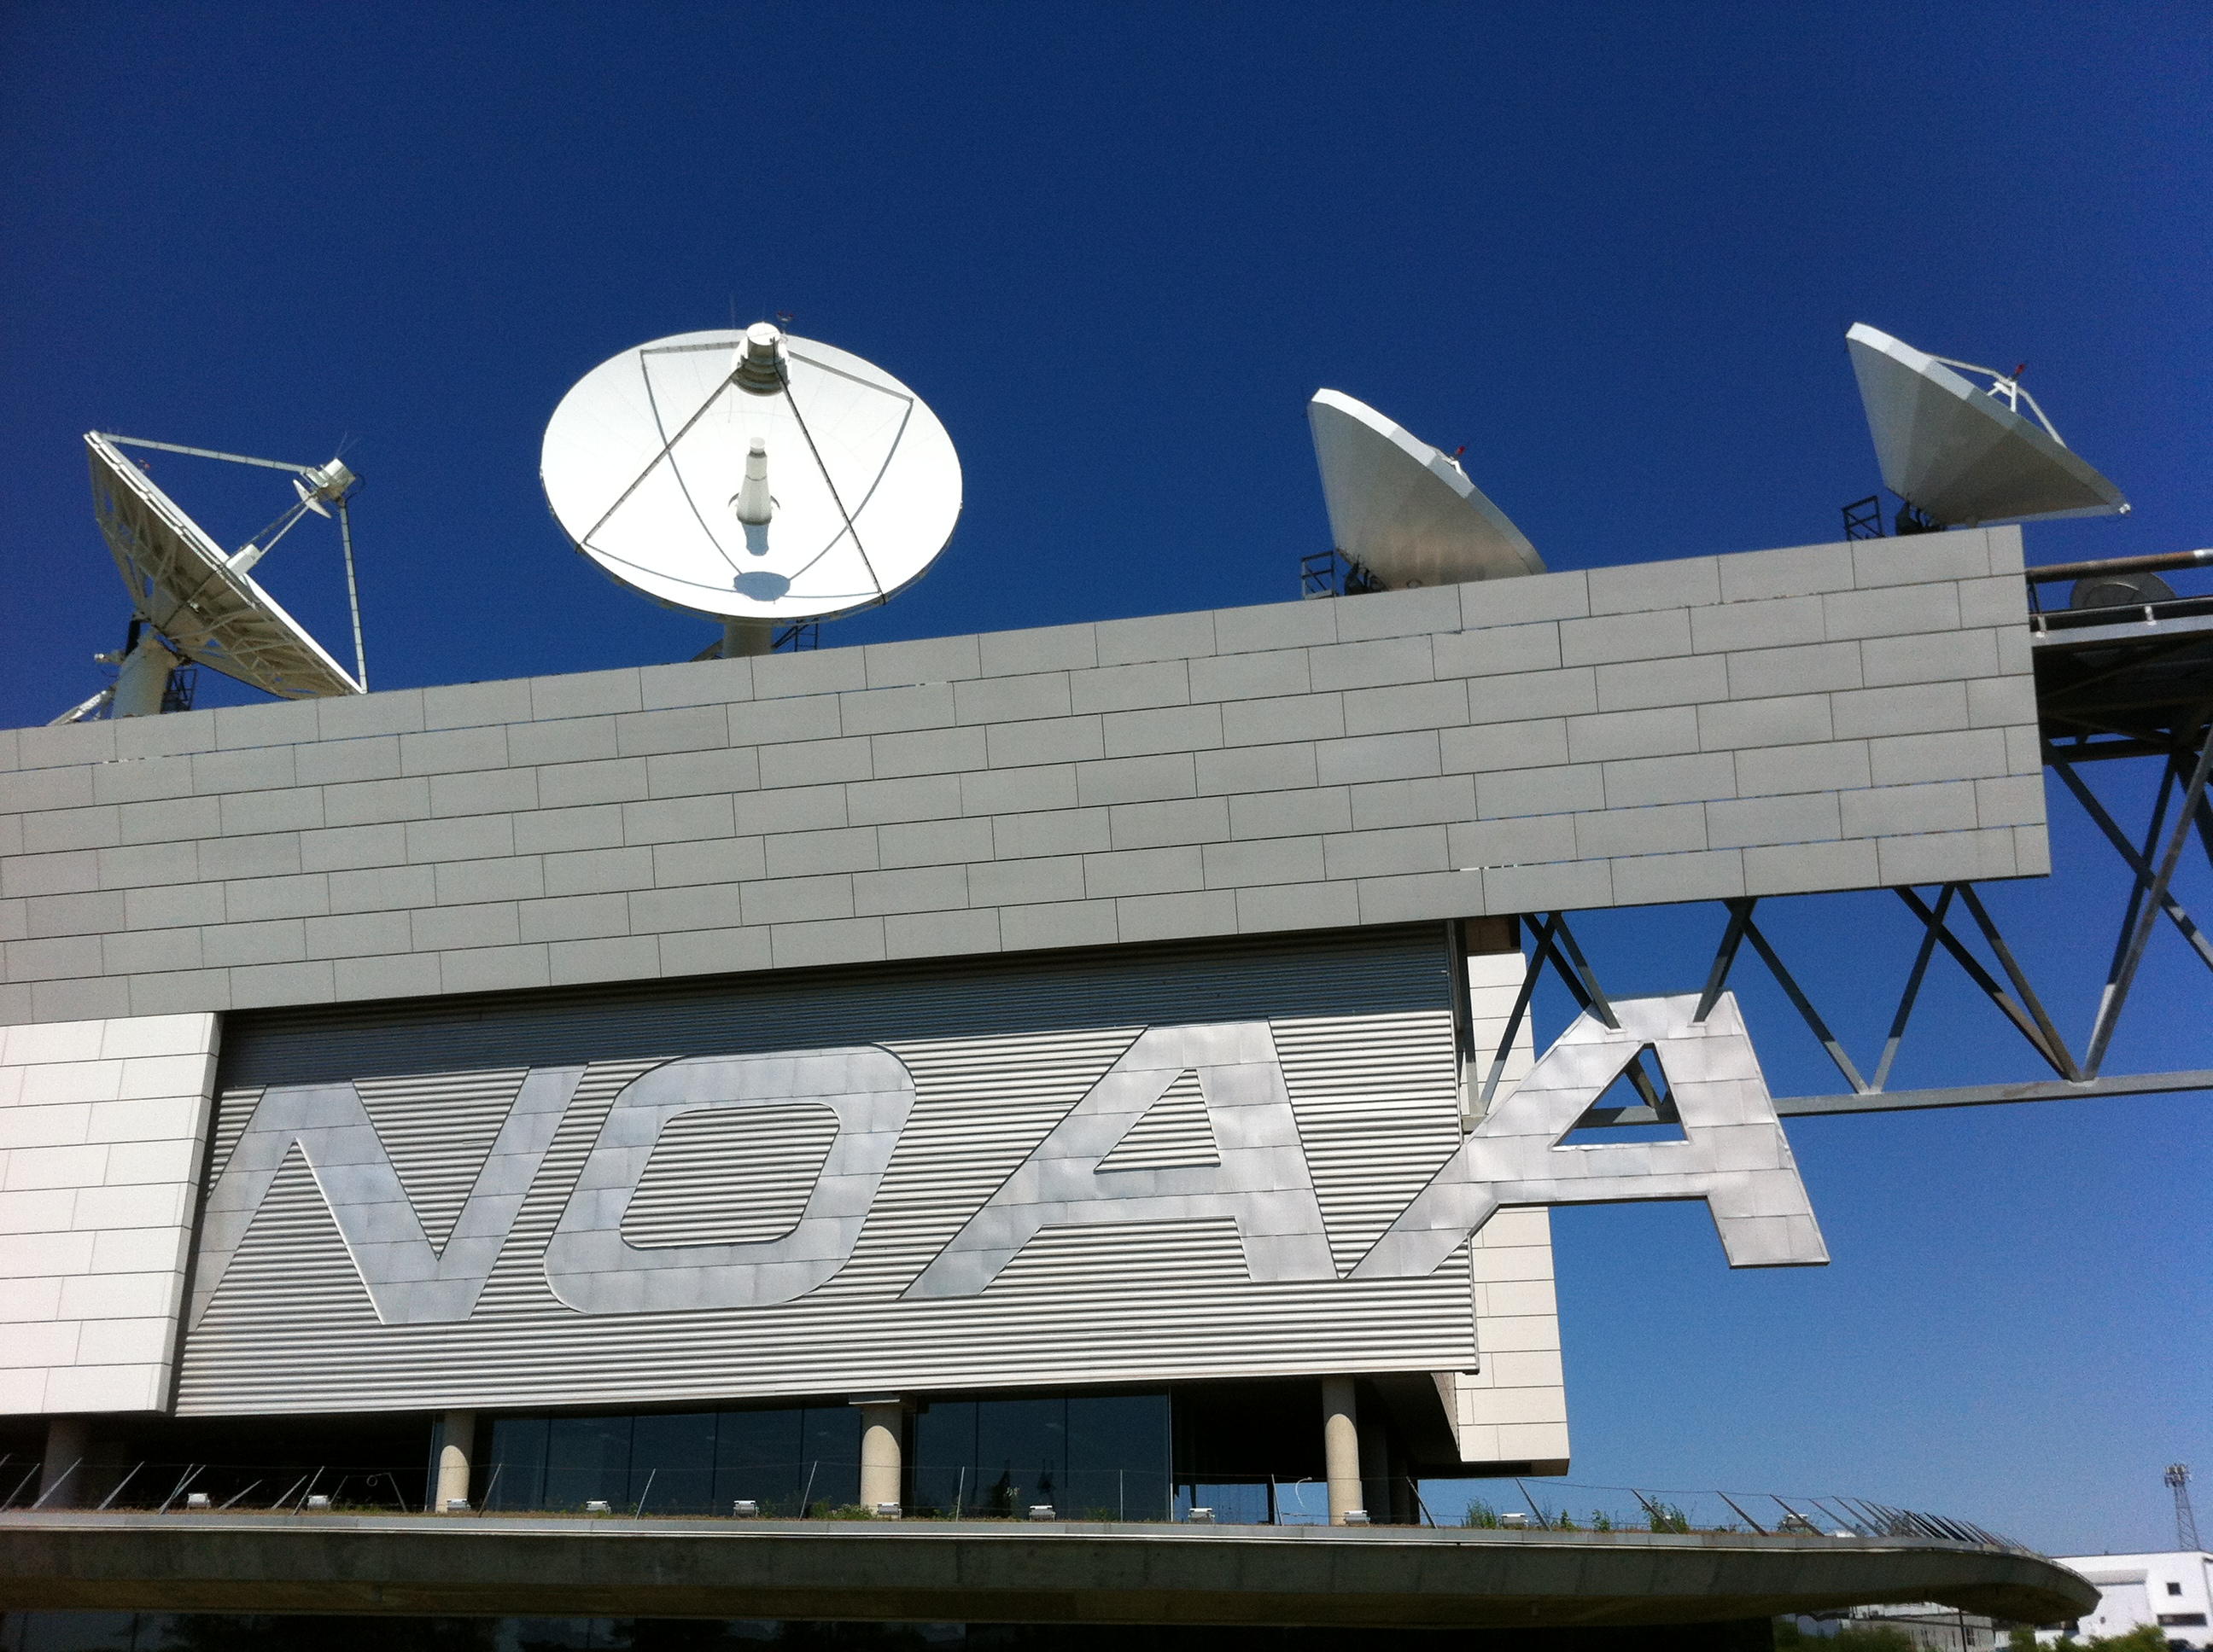
Figure 6. a) NOAA Center for Weather and Climate Prediction (NCWCP) hosts the Satellite Applications Branch and other end users with NOAA that employ satellite observations. NCWCP hosts the main numerical model center, the National Center for Environmental Prediction. b) The NOAA Satellite Operations Facility (NSOF) is the NOAA central hub for the ingestion of satellite observations from both polar orbiting and geostationary satellites. This is also the site of the Space Operations Control Center (SOCC) who oversee the US Geostationary and Polar-orbiting (POES and DMSP) satellites.

Table 1. This list outlines datasets available from NOAA/NESDIS Office of Satellite and Product Operations (OSPO). Satellite names in white are geostationary, while those listed in yellow are polar orbiting.
Satellite | Visible | Shortwave Infrared | Water Vapor | Infrared | Longwave Infrared
GOES-East | Yes | Yes | Yes | Yes | Yes
GOES-West | Yes | Yes | Yes | Yes | Yes
Meteosat-10 | Yes | Yes | Yes | Yes | Yes
Meteosat-7 | Yes | No | Yes | Yes | No
MTSAT-2 | Yes | Yes | Yes | Yes | Yes
NOAA-15 | Yes | Yes | No | Yes | Yes
NOAA-16 | Yes | Yes | No | Yes | Yes
NOAA-18 | Yes | Yes | No | Yes | Yes
NOAA-19 | Yes | Yes | No | Yes | Yes
Metop-A | Yes | Yes | No | Yes | Yes
Metop-B | Yes | Yes | No | Yes | Yes
Aqua | Yes | Yes | Yes | Yes | Yes
Terra | Yes | Yes | Yes | Yes | Yes
Suomi-NPP | Yes | Yes | No | Yes | Yes

B.1.4. AFWA

The US Air Force’s Weather Agency (AFWA) is another source for global satellite datasets. The primary dataset they host are the DMSP polar orbiting satellite series. AWFA represents another source of imagery and data products to support USAP meteorological satellite needs. After many years of discussion, DMSP observations are now acquired at McMurdo Station, and relayed through the McMurdo Ground Station (MGS). Data and instructions for the reading of the data are made available here: http://ngdc.noaa.gov/eog/mcmurdo.html Unfortunately, there has been no funding for the development of the software to read this data into some if not all of the existing USAP meteorological infrastructure (e.g. AMRC operations, etc.). Data made available via this method is also subject to delays (on the order of up to several hours), which does impact the usability for some operations and forecasting.

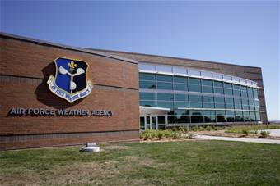
Figure 7. AFWA – the Lt. Gen. Thomas S. Moorman Building is the headquarters for the Air Force Weather Agency (AFWA) shown here (Courtesy U.S. Air Force photo by Ryan Hansen)

B.1.5. AMRC and SSEC Data Center

As a participant and NSF grantee in the USAP, the AMRC has been a window into broader data holdings. The AMRC is co-located with SSEC Data Center at UW-Madison. The SSEC Data Center is host to a world-class data center. Beyond AMRC’s signature satellite composites, the SSEC Data Center offers a vareity of geostationary and polar orbiting satellite imagery (Table 2). This collection is a larger set than available from NOAA/NESDIS/OSPO as SSEC generally offers more geostationary satellite observations than are considered operational by NOAA. Also like the other data centers within the US (AWFA and NOAA), some datasets are delayed in their availability especially the relay of NOAA/POES, MetOp, etc. polar-orbiting satellite observations, which would be of most value for real-time applications within the USAP (operations, forecasting, etc.). A variety of other non-satellite meteorological datasets are available as well.

a. b. 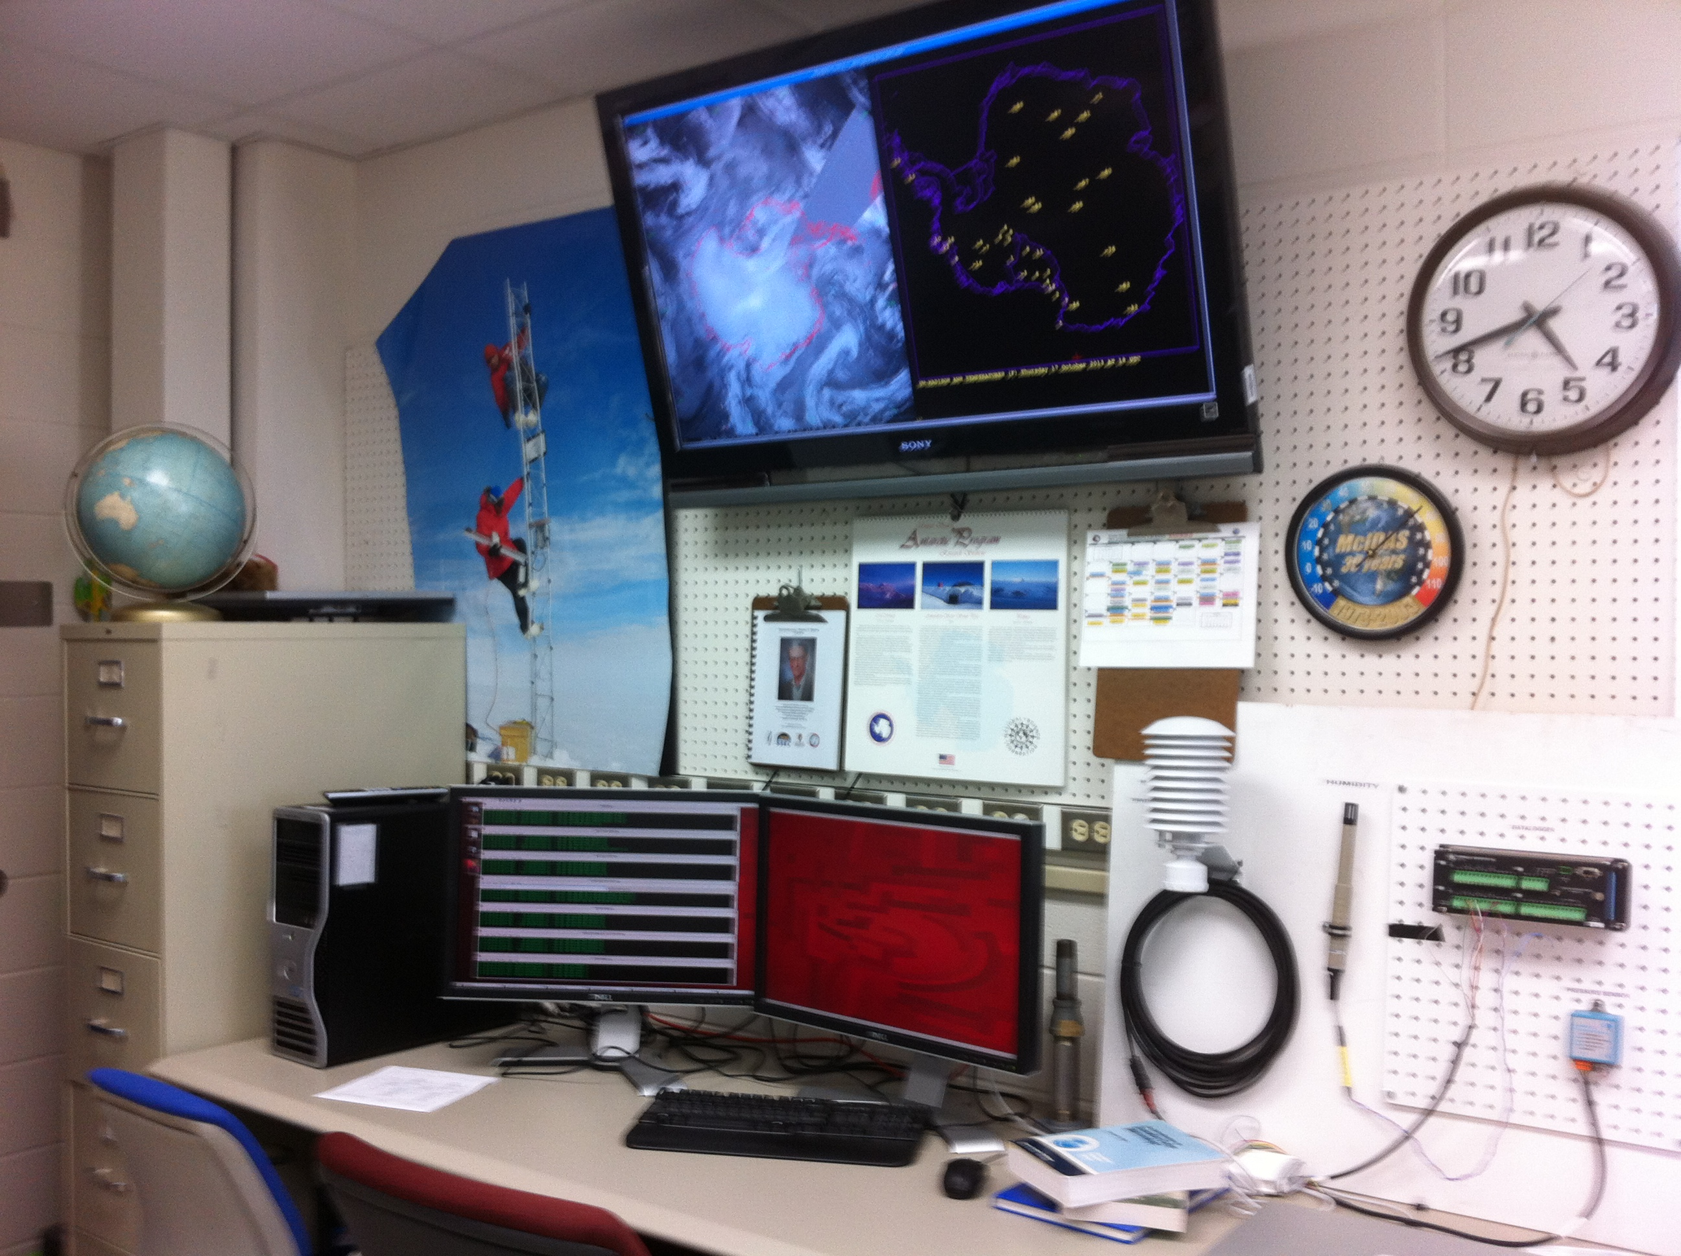
Figure 8. a) The SSEC at the UW-Madison hosts a world class Data Center, as seen here with a subset of its satellite antenna systems on the roof of the Atmospheric, Oceanic and Space Science Building b) The AMRC is housed within SSEC and is a grantee of the NSF focusing on Antarctic observational weather research.

Table 2. Table of Data Offerings from SSEC Data Center.
Satellite | Point Source | Numerical Model/Gridded Analysis | Alpha-Numeric | Satellite Navigation
GOES-East | Synoptic | GFS – NOAA | NOAAport | GOES
GOES-West | METAR | UKMET |  | NOAA/POES
NOAA/POES | Radiosonde | ECMWF |  | Two Line Element
MetOp | Aircraft | Sea Surface Temp.
Terra |  | Ice Concentration
Aqua
Meteosat-7
Meteosat-10
MTSAT-2
FY-2D
FY-2E
Kalpana-1
COMS-1

B.1.6. Commercial

There are various commercial providers of weather satellite information. Some vendors offer a variety of satellite observations. The source of the data may, in the end, be from the same sources already discussed above from rebroadcasts and relays from NOAA or from other partners. Several vendors including SeaSpace, Lockheed Martin, Unisys, Harris and others may offer this service for a fee.

B.2. Recommendations

Recommendation #1: A multi-prong approach in the current fiscal and limited satellite availability environments should be taken to ensure access to satellite observations to support both operational weather forecasting and research activities associated with the USAP. Hence, the USAP needs to have reliable access to direct broadcast satellite data available from McMurdo and Palmer Stations as well as access to data from partner organizations (e.g. AFWA, NOAA, AMRC, etc).

It is clear that timely satellite observations are essential for weather forecasting and other logistical operational decision-making. The quickest availability of satellite observational datasets is made via direct broadcast reception systems located at McMurdo Station and Palmer Station. Taking into account acquisition time, and adding on processing time, and lag for product distribution, datasets are generally available in under an hour to roughly 35 minutes (ROF forecasters, pers comms., 2013). Relays of captured data at McMurdo’s JPSS data receptors (be it DMSP or MetOp) are not timely enough for these critical applications within the USAP. DMSP observations that are captured at McMurdo are on the order of two hours delayed when made available in the United States. Other similar methods, such as “store and forward” can place data as much as three hours to perhaps several more hours delayed. It is not clear that timeliness could be improved even with a means for intercepting data locally at the receptors for processing at McMurdo Station. Hence, having a basic direct broadcast reception system is essential for the USAP. Even Palmer Station, whose operations could live with real-time satellite observations made available via the Web, for example, have found that other sources have not proven reliable or offered the data in a high enough resolution to always meet the stations needs (Grant, pers comms., 2013).

This recommendation also demands that the NSF/USAP should be working to establish partnerships with NOAA and/or AWFA as well as within its own grantee community (e.g. AMRC/SSEC) to have access to alterative feeds of satellite observations to support the real-time needs of forecasting and operational logistics. While some of these would be or could be redundant with what may be made available with a fully exploited direct broadcast system, they represent a backup in the unfortunate event of failure of communications (e.g. Internet) with the direct broadcast system(s) output or with the direct broadcast system(s) themselves. These alternative feeds will provide some satellite observations not captured by the direct broadcast system, as there can only be so many satellite passes captured by the existing or future direct broadcast systems at McMurdo and Palmer Stations.

Recommendation #2: The USAP needs to develop a more comprehensive plan for the future of satellite observation availability for primarily its weather forecasting and operational logistics support needs. This plan must include accommodations for training and adoption of new capabilities offered on new satellite series. Secondarily, it needs to also consider the use of this data in support of the USAP research community activities, as appropriate.

Despite the impending reduction of available satellites, there currently is only a limited framework in place or being considered within the USAP to utilize other non-traditional satellites. For example, the availability of newer satellites like Landsat-8 may be of value for both logistical operations as well as forecasting uses. Landsat’s new sensor does have an infrared channel as a part of its imager suite. Training forecasters to be exposed and work with newer sensors such as from Suomi-NPP VIIRS, as well as exploit more of its capabilities beyond basic imagery usage, is critical for both continuity and improvements in the forecast process. Figure 9 and figure 10 are examples of newer capabilities found in the Day Night Band on the VIIRS image that may be of benefit to the weather forecasters – using visible imagery during nighttime operations.

With a majority of weather forecast operations having been moved off continent requiring the need for satellite observations at the ROF and with the research community using the satellite observations, there is unfortunately multiple copies of the direct broadcast data received at McMurdo and Palmer Stations moved off continent (Figure 11). While some derived products such as AMV or AWS are small and not a concern to move off the continent, other raw or derived data are much too large to send via the communications at the USAP stations. This double or in some cases triple copies of data from the continent to the continental US needs to be evaluated to see if they can be minimized. The reasons for the rise of multiple copies of the data moving off continent include a) the different applications of the data and in particular, the separation of operations and research (Figure 11), b) inability to send all of the data back to the US due to its size, which drives subsection/reduction of the data to be application and end-user specific, and c) file format difference requirements between end users. Finding a solution to better share the data is needed here, including the funding to allow all parties to integrate the lowest common format in their operations that can be provided via the limited bandwidth available to the USAP for moving direct broadcast data.

Figure 9. The Southern Lights, or the Aurora Australis, as seen from the VIIRS on the Suomi-NPP satellite from June 25, 2012 at 2:44 UTC. (Courtesy Marian Mateling, AMRC)
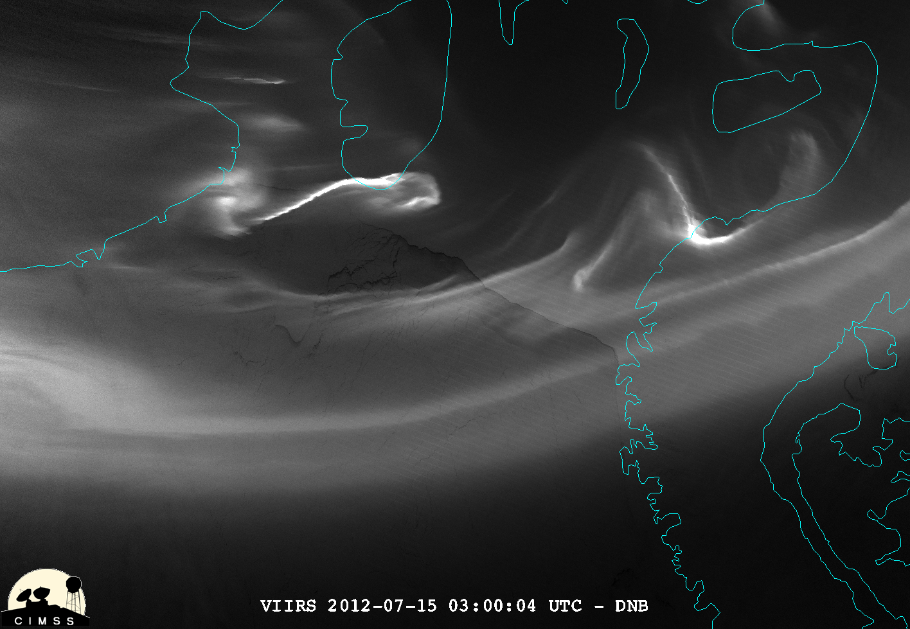
Figure 10. A VIIRS Day Night Band (DNB) image from July 15, 2012at 3 UTC over the Ronne Ice Shelf and Weddle Sea region of the Antarctic not only showing the Aurora Australis as well as the sea ice features below. (Image courtesy of William Straka, III, Cooperative Institute for Meteorological Satellite Studies/SSEC/UW-Madison).

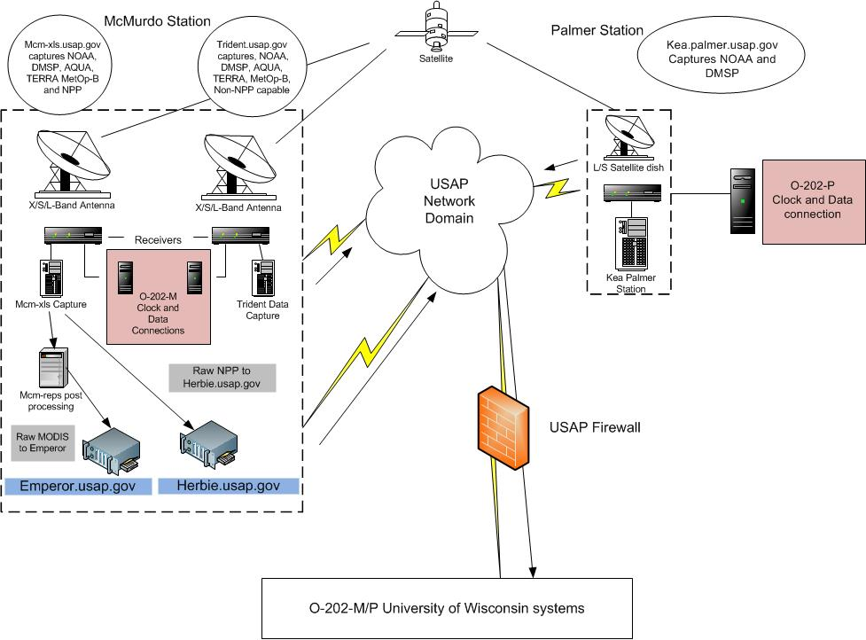
Figure 11. This diagram outlines USAP direct broadcast satellite data flow. It also shows how data is relayed twice or occasionally three times in some cases (from the TeraScan systems as well as the AMRC systems identified here). This is mostly due to the separation of operations and research as well as the differences in data format usage by the different groups. (Courtesy of Andy Archer, ASC/USAP)

Recommendation #3: …

C. Meteorological Data Exchange

The value of meteorological data sets, in particularly applied in real-time weather forecasting and operational logistics, demand communications and thus the ability to exchange, share, distribute, etc. For example, in reviewing the commonly used meteorological datasets typically used by forecasters include numerical model output including AMPS, the US Navy Operational Global Atmospheric Prediction System (NOGAPS) and NOAA’s Global Forecast System (GFS) model, upper-air/weather balloon observations, surface observations, and occasional aircraft observations (Cayette, pers comms., 2013). Most all of these datasets require meteorological data exchange for the observations. Several methods for accomplishing this data sharing are outlined here.

C.1. Review

C.1.1. AFTN and GTS

Aeronautical Fixed Telecommunications Network (AFTN) is used primarily by the McMurdo Weather to relay a series of meteorological data and messages to the Global Telecommunication System (GTS). Primarily, synoptic or staffed observations from McMurdo Station itself, observations from the nearby airfields (Pegasus Field, Ice Runway and when open, Williams Field) in a format known as METAR, along with weather balloon (also called radiosonde or rawinsonde) observations are provided this way. The terminal aerodrome forecasts (TAF) are also made available for the nearby. One dataset that was historically made available to GTS via AFTN and no longer is are aircraft reports (AIREPS) from the intercontinental flights between McMurdo and Christchurch, NZ.

South Pole and Palmer also provide data to the GTS, but do not use the AFTN as the relay. Rather, observations from these sites are sent via Iridium communications and then provided to NOAA, who in turn places the observations on the GTS. NOAA within the United States is the official civilian link to the GTS, as it is the representative to the group that oversees the GTS, the World Meteorological Organization. Both South Pole and Palmer relay synoptic or staffed observations. METAR observations along with weather balloon observations are also taken by South Pole Station and provided to GTS (These types of observation are not taken from Palmer Station).

US AWS program overseen the University of Wisconsin (UW-Madison) also provides its observations and climate summaries to the GTS, of a select set of AWS (not all are made available in some cases). Other international AWS do the same. The synoptic observations are relayed two ways: 1) via the primary communication platform used on most AWS known as CLS/Service Argos who decode and inject the AWS observations directly to GTS at CLS in Largo, Maryland (there are backups in other locations) and 2) via the British Antarctic Survey (BAS) with direct access to decoded real-time observations from the AMRC at UW-Madison. The observations at the AMRC are made available via CLS/Service Argos embedded in the real-time reception of the NOAA High Resolution Picture Transmission (HRPT) observations at McMurdo Station and Palmer Station, and the NOAA rebroadcast transmission at UW-Madison/SSEC Data Center in the NOAA Global Area Coverage (GAC) data sets. The first method has been in use for many years, however, with difficulties in keep the list of stations and decoding updated has been a challenge. Difficulties with this in the past gave rise to the second method with BAS directly acquiring observations from the real-time collection at AMRC to process into synoptic message format. CLIMAT messages are created and provided to NOAA for posting on GTS by the UW-Madison AWS project with separate funding from NOAA National Climatic Data Center, as this is not a part of its project funding from the NSF.

C.1.2. Antarctic-IDD/LDM

With the increase in security across the USAP, a loss of other data exchange means and encouragement from the NSF, the US Antarctic meteorological community created an Antarctic-Internet Data Distribution (Antarctic-IDD) System. The Antarctic-IDD uses the NSF funded Local Data Management (LDM) software to exchange operational and research meteorological data across the USAP and, at times, include portions of the international meteorological enterprise (Figure 12). This system has become a primary, and in some cases, the only means for sharing of some critical data between operations and science as seen in Figure 13.

As of the writing of this report, discussions are underway to have the USAP formally insert an LDM node at the ASC in Centennial, Colorado that would serve as the relay between the domestic Antarctic-IDD (external to the USAP network) and the full USAP network. This would include a relay to the Antarctic at McMurdo and Palmer Stations as well as other USAP network nodes including the ROF in Charleston, SC. This addition would welcome stability to the network, removing the possible fail point at the AMRC/UW-Madison. However, discussions have also discussed having the data drop out of LDM at the node in Colorado, have the data inserted into a third party system that NSF would use to control all data flow into and out of the USAP network, and then would have to be picked back up by the LDM systems inside the USAP network. This potential plan introduces extra points of failure that need to be mitigated as well as relay work that would need to be funded.

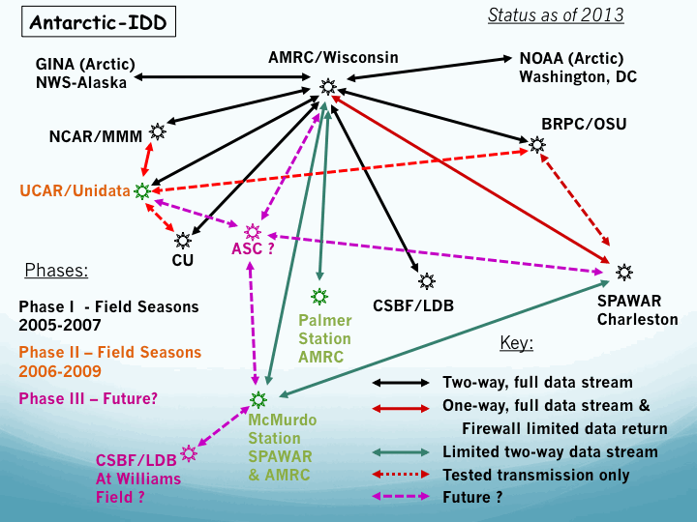
Figure 12. The network map of the Antarctic-IDD as of 2013.
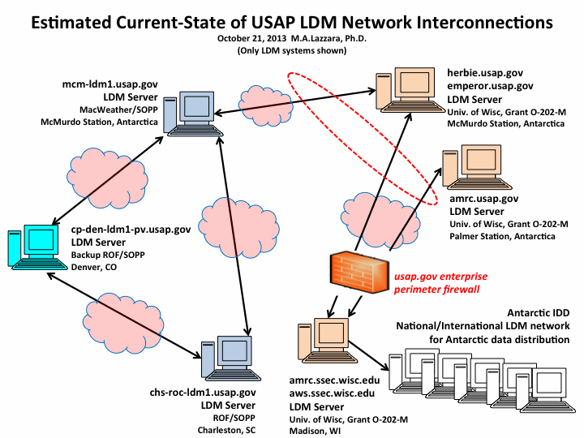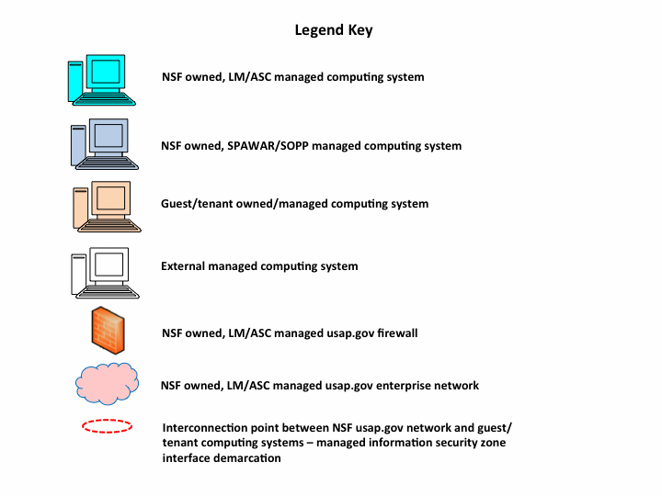
Figure 13. Basic configuration of the Antarctic-IDD or USAP LDM Network as of 2013.

C.1.3. Geostationary Relay Systems

As a part of the Global Earth Observing System of System (GEOSS), there are a series of geostationary satellite services offering data dissemination that can be received using inexpensive satellite reception equipment over a Digital Video Broadcast (DVB) or DVB-Satellite (DVB-S) formats. Over the Western Hemisphere, GEONETSCast Americas is overseen by NOAA and its contribution to the GEOSS from this portion of the world. The data stream can be found on the Intelsat-9 (IS-9) satellite and is available to all of North and South America. Including GEONETSCast, cousin satellite systems that are a part of GEOSS include:

- GEONETSCast over the Americas
- EUMETCast over Europe
- EUMETCast-Africa over Africa
- FengYunCast over Asia and Australia
- CMACast over Asia and Australia

Contributors to this data stream include a host of agencies (NOAA, NASA, INPE/CPTEC, CMA, CIMSS, EUMETSAT,etc.) from a variety of countries. Unfortunately, these data stream does not offer much in the way of Antarctic datasets.

As discussed in section B.1.3., NOAA’s NOAAport service and NOAA’s DOMSAT service are both geostationary relay systems. However, the NOAAport system carries limited Antarctic data for satellite observations. It does carry the US domestic relay of GTS content, which does include Antarctic meteorological datasets. The DOMSAT service does have polar orbiting satellite observations, which do cover the Antarctic (and embedded in them contain other datasets such as AWS observations).

C.1.4 ADDE Services

Used primarily by the AMRC and NOAA, an increasingly used data transmission and sharing protocol is the McIDAS based Abstract Data Distrbution Environment (ADDE) server set. These servers provide imagery (satellite data), point source (such as AWS or weather balloon observations), gridded (numerical modeling output such as AMPS), text (such as TAFs), and satellite navigation datasets. This protocol has been accepted transmission usage within the USAP for more than a dozen and half years. For many years, meteorological data and display products were moved back and forth from the AMRC in Wisconsin to McMurdo Station for use on station by researchers and forecasters alike. This has been reduced some, with the elimination of AMRC File Transfer Protocol (FTP) and Web servers at McMurdo Station. Today, AMRC at Wisconsin requests data from ADDE servers at McMurdo and Palmer Stations for the creation of the Antarctic composite satellite imagery or working with real-time AWS observations.

C.1.5. Secure Shell

With the implementation of Department of Homeland Security rules, the ubiquitous use of FTP servers and clients has come to an end within the USAP. Hence, more standard means of moving data files has been accomplished via SSH or Secure Shell, which includes encryption of passwords, and other features not available via older protocol such as FTP. Primarily these services are used within the USAP, such as the moving of data between TeraScan and AMRC server systems, or to acquire metadata into systems at McMurdo Station. Use of this method likely extends beyond examples outlined here. Recently, the McIDAS ADDE server system has been upgraded to now be able to exploit SSH rather than using its dedicated/assigned TCP port. It is currently not in use within the USAP due to limited funding and other higher priority tasks.

C.2. Recommendations

Recommendation #4: The creation of the Antarctic-IDD/LDM system has been a success in linking the research and operational communities within the USAP. Do not let the issues with security ruin that success or impede its progress. Include the LDM developers (who are funded by NSF-AGS) in all future discussions of the network to benefit both the Antarctic-IDD and the NSF-AGS funded effort.

Recommendation #5: Care and oversight for meteorological relay, especially to global systems such as the GTS is not as well cared for as could be (e.g. AWS observations and PIREP/AIREP observations and Palmer Station CLIMAT messages, etc.). Real-time availability of meteorological observations and other data sets are important for inclusion in numerical modeling as well as operational efforts. Support for this effort must be encouraged along with the funding to accomplish it properly.

D. Meteorological Observing

Meteorological observations are crucial for the USAP enterprise. Limited funding and reductions in on-continent staff are leading to impacts on the staffed observations made at the USAP stations. This section reviews those issues.

D.1. Review

D.1.1. McMurdo

The reduction in funding for the USAP has driven the weather operations at the airfields to no longer have airfield observers, and in their place, have air traffic control (ATC) staff make what are known as Limited Aviation Weather Reporting Station (LAWRS) type observations (FAA, 1977 and FAA, 2013). In doing so, only 18 of 24 hours of the day will be covered by human observers, with only automated obsevations being available from 3:30 pm on Saturdays until 5 pm on Sundays (local times). The remaining period of time will be covered by an automated system (FMQ-19). A newer system has been purchased and installed (a Mesotech system), and awaiting additional components to be used for LAWRS operations. These planned arrangements will limit or eliminate some types of observations, such as precipitation or no longer have weather balloon launches on Sunday mornings (local time). It may also result in limited special or SPECI weather observations when needed, but unable to be conducted due to overtasks air traffic controller.

D.1.1. Palmer Station

Palmer station meteorological observations are taken with an automated weather system on Gamage Point, near the Biolab building, called the Palmer Automated Meteorological Observing System (PalMOS) (See Figure 14). This is a complex system with quite a few instruments. The weather data it produces is widely distributed and heavily used for both scientific research and operations. Among other things, it generates synoptic weather reports every three hours that are fed to the GTS. The system is aging and some parts have failed, hence there are discussions of replacing it. No firm plans have been set to do that, however. The 2-minute weather data, collected by the automated system, is extremely useful to researchers: It's in a simple text format that's portable and easy to explain. Likewise, the monthly weather summaries (daily highs, lows, averages, etc.) that are put together by the Research Associate on station are widely liked by the science community.

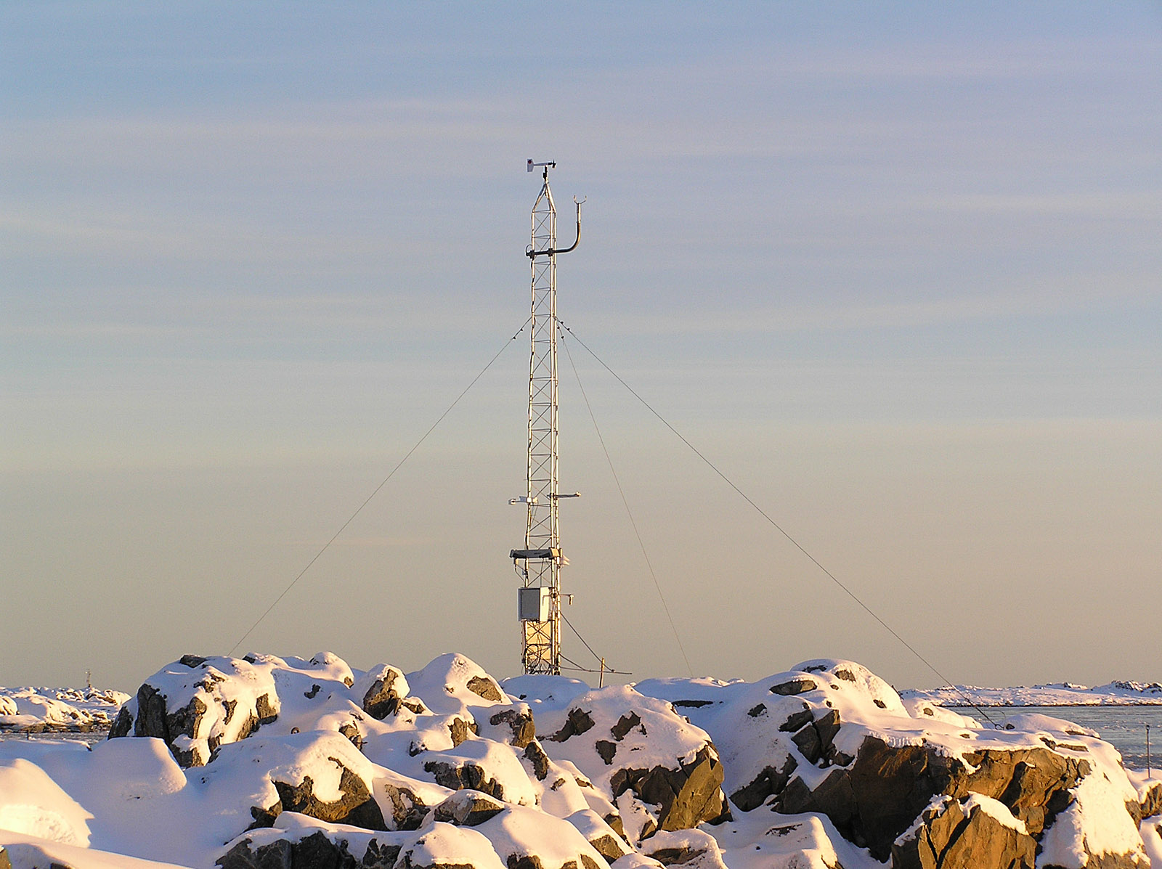
Figure 14. The PalMOS weather observation tower at Gamage Point at Palmer Station.

D.2. Recommendations

Recommendation #6: Concerns with meteorological observing: Replace the aging meteorological system at Palmer Station. Any efforts to replace this system should be community based including key users of the data, caretakers and data archivists.

Palmer Station has a critical need to ensure delivery and availability of accurate, real-time weather data. The current system is failing and there is no grantee within the USAP overseeing the system. Budgets are always doubtful, and there's no dedicated meteorologist who maintains the instrumentation and QAs the data. It falls to the station Research Associate (RA) to support the system; and they do it happily, however they may not always have the proper training or sufficient time. Additionally, the instrumentation is old and often out of calibration, and over the years the supporting software has grown quite complex. Yet according to the current RA nearly *every grantee* who comes to station wants the data, and it is used continuously to support operations and safety. Since the data goes out as synoptic reports, monthly weather summaries, and surface observations (hosted by the AMRC), countless other researchers off continent may be using it. All of the users make the assumption that the data is accurate, which is not necessarily the case. Almost every season the RA find some portion of the system has failed but nobody noticed. Without a P.I. who takes an active interest in the system, history has shown that the quality and consistency of our weather data will always be at risk. Discussions between the RA and NSF are leading to encouraging LTER participants to take a more active interest in the weather system that they, in particular, use heavily. Recently the AMRC proposed to take a more active role in the QC of the data stream of Palmer Station and other locations; however, this effort was not funded in AMRC last grant award.

Historically, the purchasing decisions with regards to Palmer’s weather needs have not been very informed of how the weather data is used. As a result, sensors are acquired that are not needed or wanted, and vendor software is often not flexible enough to meet users needs. Worse, some software/display systems used at the station are limited enough that they are never used. This costs both time and funding on what turns out to unnecessary instrumentation/software, and results in the station personnel building their own software/displays.

E. Meteorological Interactive Processing Systems

E.1. Review

To view and interact with the meteorological data streams requires a meteorological interactive processing system. Several software systems are being used across the USAP for forecasting and research use. Some systems are commercial off the shelf, some are from the research community, and others are home grown. This section outlines what systems are in use and recommendations are provided on the future.

E.1.1 MetApp

To facilitate a common linkage across desperate interactive processing system used in the USAP for forecasting, the MetApp system has been created to fill that critical role. This “interpreter” is able to ingest and display weather text products including forecasts, METAR observations, AIREP/POSREPs (aircraft weather reports and aircraft position reports). This system includes a database, and has links (some automatic, some semi-automatic) to the Antarctic-IDD/LDM system. The variety of systems linked via MetApp include TeraScan satellite output, Flight Manager systems (air traffic control systems), observer output system (e.g. radiosonde systems, and data from outside sources including from the AMRC. This system is written in Java, and deployed to McMurdo Station as well as at the ROF. MetApp and other data are managed on servers located at Mac Weather (with 2 systems), ROF (with 2 systems) and at ASC (with 1 system) providing redundant and backup solutions for any needed contingencies.

E.1.2. TeraScan

SeaSpace’s TeraScan system is the direct broadcast reception system used in the USAP. This system was first develop at McMurdo, and aided in the launch of the SeaSpace Corporation. Today, McMurdo Station hosts two reception systems, Palmer Station hosts one reception system, and on the R/V Nathanial B. Palmer research vessel (See sections B.1.1. and B.1.2.). The associated displays system, TeraVision software is installed at McMurdo Station (with 2 systems), the ROF (with 2 systems), on the N.B. Palmer (with 1 system) and at ASC in Cenntenial, Colorado (with 1 system). Currently, an older version of the TeraVision system is in use throughout the USAP, and is in need of upgrade.

E.1.3. Yosemite/Marta Systems

McMurdo Weather operations have employed the Yosemite weather display system, developed by Marta Systems. This system has the capability to not only display point source observations, but was selected for its ability to work with grib formatted numerical model output fields. The primary use for this display system has been for the display of AWS observations (both SPAWAR and UW-Madison). The ability to display numerical model observations or other data types has not been utilized.

E.1.4. McIDAS

The McIDAS system has been employed in the USAP since the inception of the AMRC in 1992. Outside of the AMRC, this system has had limited use in weather forecasting in the early 1990s. A derivative system, named MERLIN with an Antarctic specific interface that was based off of McIDAS-X was used operationally by McMurdo Weather forecast operations in the mid-1990s. Today, the McIDAS software has two systems, McIDAS-X and McIDAS-V. McIDAS-X is installed at both McMurdo and Palmer Stations, but today is limited in its use as compared to its original scope when first installed in the 1990s.

E.1.4.1 McIDAS-X

The McIDAS-X system has been the primary system use to generate the Antarctic satellite composites that have been a widely used within the USAP and beyond. This system has been used to provide displays of real-time AWS observations and other meteorological data. The McIDAS-X system is actively supporting AMRC activities, however, the McIDAS-X system is due to be sunset at the end of the current GOES satellite era (expected to be after 2020). At that time a transition to another interactive processing system will be required.

E.1.4.2 McIDAS-V

The McIDAS-V (a close cousin to the IDV or Interactive Data Viewer system developed by the NSF Unidata project), currently not in operational use within the USAP, has been investigated by both SOPP and AMRC for Antarctic applications. Advantages include its ability to work with a variety of data formats, freely available, and works on a variety of platforms, including Windows, Mac, and Linux. Some data types used within the USAP are not yet demonstrated with the system, but may be possible. It does have advantages over the McIDAS-X with its 3 dimensional display abilities. The disadvantage of this system at its current stage of its development is McIDAS-V requirements to run on higher-end computing platforms to work with large satellite datasets. While McIDAS-V is constantly being improved, some customization work is needed as well as having the Antarctic meteorological community meet the learning curve this system presents. These requirements must be hurdled for this tool to be employed for Antarctic applications.

E.1.5. Google Earth

In the last several years, Google Earth has become a very commonly used tool in Mac Weather and the ROF as well as a nearly standard tool in most computer systems. Currently Mac Weather and ROF plot weather observations, overlay the Antarctic satellite composites and track aircraft in Google Earth.

Google Earth represents the first step into the larger world of Geographical Information Systems (GIS) type systems. While GIS types of systems have been employed for many years within the USAP, typically on the research side or in support of research, this is now expanding. Efforts by the Polar Geospatial Consortium (PGC) group at the University of Minnesota have brought very high-resolution satellite (e.g. GeoEye) and mapping capabilities to the NSF polar programs (both Arctic and Antarctic).

E.1.6. Web Resources

The weather operations at Mac Weather along with the ROF use a set of web sites, often outside the prevue of the USAP to support their forecasting effort. The Navy JMV, the NCAR AMPS, and AMRC web sites are all used. Palmer Station utilizes Chilean web sites to supplement is meteorological displays.

We use PalMOS's data as well as the TeraScan imagery to produce real-time displays; most of the software was written in-house for local web-based display. Additionally, we retrieve imagery and data products from the web to support operations. The Internet retrievals include: - Isobar imagery from University of Wisconsin - Isobar, wave, and wind charts from Chile, to support ship operations - Ice extent charts from the NIC - MODIS imagery from NASA - RadarSat imagery from BAS/EU - Custom ice concentration charts for the Anvers Island region, from the NIC - Emailed weather forecasts from SPAWAR/Charleston - Continental weather conditions and forecasts from Weather Underground

E.1.7. Fixed Displays

Mac Weather, exclusively, uses two “fixed” displays: one for the runway surface observations made by the FMQ-19 system at Pegasus Field and the other for Building 165, where Mac Weather is located and the official synoptic observations are made for McMurdo Station. Both of these systems are display the surface observations made at both locations.

E.1.8. Miscellaneous

The Universal RAwinsonde OBservation (RAOB) upper air display software is commonly used at both Mac Weather and the ROF to visualize the output of McMurdo Station’s twice daily launched weather balloon. A Graphical Viewer/METAR Display system also used and is commonly referred to as Black Island Display but will display any surface observation in the MetApps database. These additional software systems round out the various displays used within the USAP.

At Palmer Station, the weather display system has become a miscellaneous software collection. The current system uses Microsoft Excel, Matlab, HTML, along with shell scripts, and proprietary executable binary programs without the source code. As a result this system is complex and difficult to maintain.

E.2. Recommendations

Recommendation #7: For MacWeather and ROF: With a host of various interactive processing systems used across the USAP, the effectiveness of using so many different systems, means and methods should be re-evaluated. While there will be no “one-size-fits-all” solution, some level of reducing the number of platforms and software to work with data should be pursued. Even having roughly 3 systems would perhaps be an ideal goal. One system should be a fusion system that would allow nearly all data types be viewable/useable for forecasters, and provide redundancy. Additionally, systems employ should have the ability for future expansion, allow creativity in product and display creation along with the ability to merge datasets and alarm forecasters when severe weather limits are met. Such an effort to evolve to a newer/smaller toolbox of interactive processing should include forecasters, meteorology managers, and minor representation from the meteorological research/science community.

Recommendation #8: For Palmer Station: Weather resources should match community needs. As with the need to build a team to work on scoping out a future smaller toolbox for weather forecasting at McMurdo Station, the same is the case for the Palmer Station. So aside from reliable and well-maintained instrumentation a simple, easy-to-maintain software system that addresses the immediate operational needs of the Palmer community (typically nice visual displays and graphs) and the long-term requirements for scientific users (observations archived in a simple format at a high temporal resolution, similar to our 2-minute data files) are required.

F. Acknowledgements

Thanks to Cornell “Corky” Bower (SRC/SOPP), Andy Archer (ASC/LM), Glenn Grant (ASC/LM), Dave Mikolajczyk (AMRC/UW-Madison), Bonnie Morgan (NOAA/NESDIS), Linda Keller (AMRC/UW-Madison), Art Cayette (SOPP), Chester Clogston (SOPP) and Pat Smith (PLR/NSF). Without their input, lively discussions, this report would not have come to life. Special thanks goes to Matt Rushing for his support of this project.

G. References

FAA, 2013: Weather/Visibility–Limited Aviation Weather Reporting Station (LAWRS) http://www.faa.gov/air_traffic/publications/atpubs/fac/0209.html

FAA, 1977: Limited Aviation Weather Reporting Station (LAWRS) http://www.faa.gov/regulations_policies/orders_notices/index.cfm/go/document.information/documentID/10729

Lazzara, M.A., L.M. Keller, C.R. Stearns, J.E. Thom, and G.A. Wiedner, 2003: Antarctic Satellite Meteorology: Applications for Weather Forecasting. Mon. Wea. Rev., 131, 371-383.

Lazzara, M.A., A. Coletti, B.L. Diedrich, 2011: The possibilities of polar meteorology, environmental remote sensing, communications and space weather applications from Artificial Lagrange Orbit. J. Adv. Space Res., 48, doi:10.1016/j.asr.2011.04.026.

H. Appendix

